**Year 2**

Maths

Our mathematical focus this half term is fractions. We will be learning to make equal parts; recognise a half, a quarter and a third; find a half, a quarter and a third; understand unit and non-unit fractions; understand the equivalence of a half and two quarters; count in fractions and solve problems involving fractions.

English

We will continue with our RWI phonics programme as well as introducing the children to a new writing approach ‘The Write Stuff’. Children will be learning how to write a persuasive letter, a poem and a story based on Little Red Riding Hood. In preparation for Key Stage 2, we will be introducing the children to the Accelerated Reader programme where they can access a wider range of both paper and electronic books.

**Spring 2**

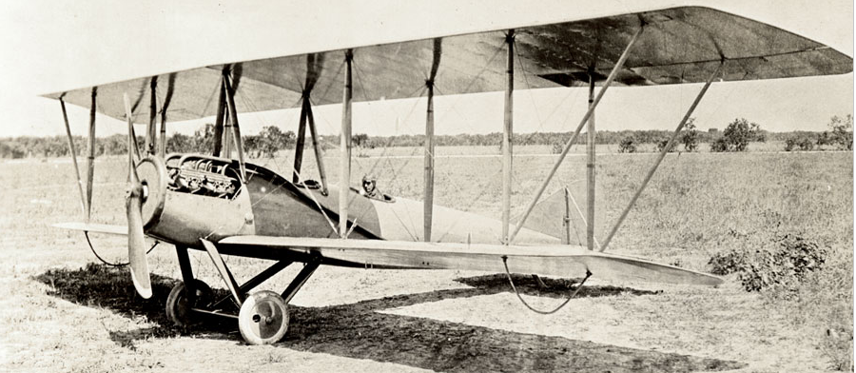

Music

In music we will be learning about standard notation and learning how to play the glockenspiel.

Science

We will be continuing our learning about plants up until Easter. We will be learning about the life cycle of a plant as well as the different foods that grow on plants. We will be tasting a selection of different fruits and vegetables too! Why not have a go at making a fruit salad or a tasty bowl of vegetable soup? We will also be ‘Making the Difference’ by planting a variety of plants in our outdoor area to make it look more attractive and colourful!

History

This half term we will be studying the significance of important people from the past. We will be learning about the history of flight and how the Wright brothers and Amy Johnson became famous.

PE

Our indoor PE lessons will focus on us using our bodies to create shape, movements and actions through dance. Our outdoor PE lessons will focus on jumping in a variety of ways and throwing with good technique in athletics.

Art

In Art we will be learning about sculptures. The children will be working with a partner to create a sculpture in a superhero pose using pipe cleaners and playdough. We will then be looking more closely at facial expressions and emotions then creating these in our sculptures.

Computing

In our computing lessons we will be using Purple Mash to create spreadsheets and make music by experimenting with different sounds and tempo.

RE

We will continue to learn about the importance of how and why we celebrate special and sacred in Christianity and Judaism.

PSHE

Our PSHE focus is health and wellbeing. We will be naming the different parts of the body and learning about how our bodies change as they grow.