**Year 4**

Maths

**Time** – Telling the time to 1 minute and 5 minutes, AM and PM, 24 hour clock

**Times Tables** – Practising in preparation for the Times Tables test

**Statistics** – Interpret charts, Comparison, Sum and difference, Line graphs

**Angles and shapes** – Identify, Compare and Order angles, Triangles, Quadrilaterals, Symmetry

**Position and direction** – co-ordinates

English

Narrative – The Whale – mystery story – based on the picture book, The Whale, children will write

Non-Chronological report – holiday brochure – using our geography knowledge, we will write a holiday brochure about a mountainous region.

Reading – Focus on comprehension and the different question types – Loki – A Bad God’s Guide to Being Good

**Summer 2**

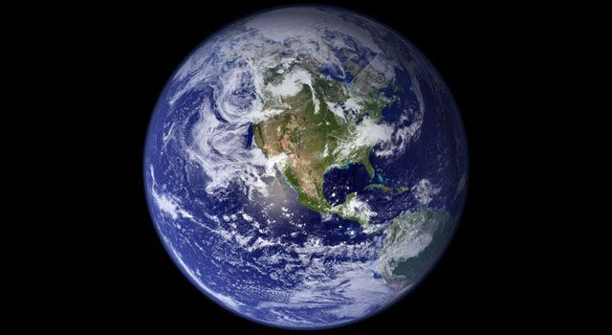

PSHE

In PSHE, we are learning about communication; in particular, how to respond to others and how to express our opinions, even when they are different to our friends. We will also be learning about money, focussing on our own spending choices and how to manage money.

Computing

Animation – We will be planning and creating our own animations to share with others (Purple Mash)

DT

In DT, we will be making pavilions for our structure unit of work. We will use craft materials such as plasticine, toothpicks, A4 Card, matchsticks lolly sticks, straws, pipe cleaners and glue guns. The aim will be to make the structure as strong as possible.

PE

Hockey – We will be learning how to dribble the ball, how to use power to hit the ball and how to work as a team.

Invasion Games – We will be working on speed and agility, defending a goal, scoring a goal and footwork.

Swimming (4H)

Science

**Sound**

In science, we will be learning all about sound. Some of the questions we will answer are:

How are sounds made?

How do we hear sounds?

What happens when we move away from a source of sound?

RE

**What can we learn from religions when deciding what is right and wrong?**

We will be looking at how religion helps people to make decisions in their lives. We will be answering questions such as: How have religious teachings helped to affect somebody’s actions?

What rules are important?

Geography

**How does the shape of the land change (Mountains)?**

We will look at famous mountains and discuss types of mountains, eg. fold, volcanic. We will also look at mountain climates and use mountain vocabulary such as foot, summit.

Music (4H)

**Singing skills**

In music, we will be practising our singing skills. We will be learning how to warm up our voices, how to use expression when we sing and how to identify changes in tempo and tone.

**Rhythms**

We will also be using claves/sticks to follow notations