**Year 4**

English

Non – Fiction – Factual tour of the digestive system – Focus on the language used, sentence structure and description.

Narrative – Mystery – The Whale – We will be looking at sentence structure, dialogue and apostrophes.

Reading – Why the Whales Came – Michael Morpurgo. The focus this half term will be on the characters thoughts and feelings and author’s use of language.

Maths

Decimals – Writing, comparing, ordering and rounding decimals

Money – Pounds and Pence, estimating, converting, adding and subtracting money

Time – Telling the time to 1 minute and 5 minutes, AM and PM, 24 hour clock

Times Tables – Practising in preparation for the Times Tables test

**Summer 1**

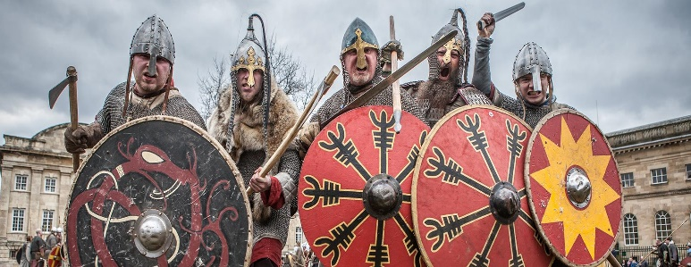

Spanish

**Members of the family**

We will be learning to talk about our immediate family, our extended family, talking about family member’s names and ages and we will describe family members. We will then be writing this knowledge in a paragraph.

PSHE

What makes a balanced diet?

During this unit, children will learn about the different food groups, they will understand where food comes from and they will learn about the different jobs that involve food.

RE

**What does it mean to be a Hindu in Britain today?**

How do Hindu’s show their faith?

A Hindu life, what is important?

Why was Mahatma Gandhi a Hindu hero?

What is it like to be a Hindu in Britain today?

**History**

**Invaders and Settlements – The Anglo-Saxons and Vikings**

Who were the Anglo-Saxons and the Vikings?

Where did they come from?

When did they arrive in Britain?

What changes did they bring to Britain?

Art

**Every picture tells a story**

During this topic, children will study famous paintings learning to describe the pieces, including the formal elements (shape, form, tone, texture, pattern, colour.) They will then use this as inspiration for different tasks.

Science

**The Digestive System**

What is the digestive system?

What parts of the body are involved in digestion?

Why is digestion important?

**Teeth**

What role do teeth have in the digestive system?

What different teeth do we have? What are their jobs?

Music

**Singing skills**

In music, we will be practising our singing skills by learning some songs about the Anglo Saxons. We will be learning how to warm up our voices, how to use expression when we sing and how to identify changes in tempo and tone.

PE

Rounders – We will be learning how to bowl underarm with accuracy, how to stand correctly when batting, where to stand when fielding and how to judge when to run.

Invasion Games Skills – We will be learning how to invade space. how to defend, how to strategise and work as a team.

Swimming will continue for 4C