**Year 4**

English

Narrative – The Feast – Our writing will focus on apostrophes for possession, repetition for effect, short sentences, similes and using inference in our writing (show not tell.)

Newspaper Article – The Creature – Focussing on the aspects of an article e.g. headline, strapline, sequencing of events and eye witness quotes.

Reading Lessons – We will be reading Escape from Pompeii and using this as a basis for our comprehension.

Maths

This half term we will be learning all about Multiplication including multiplying 3 numbers, multiplying a 2 digit number by a 1 digit number and a 3 digit number by a 1 digit number. We will be learning division of 2 digit by a 1 digit number and a 3 digit number divided by a 1 digit number. We will also be working out the area of shapes and completing work on fractions and decimals including mixed number fractions and writing tenths and decimals.

**Spring 1**

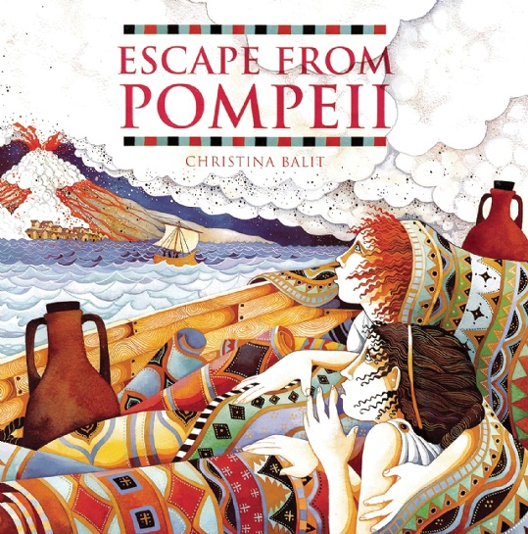

Spanish

We will be starting our Spanish lessons by learning Greetings. This includes asking and answering questions about how we are feeling, asking and answering questions about names and learning the

numbers to 15.

Music

In Music we will be learning how to improve our Singing skills, learning all about Roman Instruments and “Rocking Romans”.

PSHE

We will be focussing on ourselves this half term and thinking about our strengths, our aims, how we can achieve our dreams and our aspirations, and the steps we need to get there.

PE

Tuesday – 4H – Swimming until January 25th.

4C – Tag Rugby – Building on our invasion games skills, we will be using teamwork, defence and using the space to be successful.

Friday – Roman Dance – We will be creating a Roman Dance using whole group choreography including actions, good posture and extension.

Science

We will be learning about different materials. We will be classifying them into solids, liquids and gasses and working out what makes them these. We will also observe different materials when they freeze and melt and explain what happens to them. We will know what freezing and boiling means in scientific terms and how changes of state affect the water cycle.

History

In history, we will be learning all about the Romans. We will be looking at how they invaded Britain, how Julius Caesar was a successful Emperor, the differences between life in Britain and Rome at that time and also the influences the Romans have on our lives today.

Art

We will be looking at the work of William Morris in more detail, focussing on his printing designs and how he used this to create the first wallpapers. We will then be using this inspiration to create our own artwork.

RE

We will be looking at different festivals and why they are important. We will be investigating a range of celebrations from different religions: Islam, Hinduism, Judaism and Christianity and why they are celebrated.