**Year 5**

English

Non-fiction

This half term we will be writing a persuasive letter all about fair trade from 3rd world countries. We will be using the book ‘Kick’ as the hook to our writing.

Reading

During this half term we will be using Rudyard Kipling’s ‘Just so Stories’ as our reading text. We will be answering a range of questions about each short story. We will also look at the vocabulary in the book to increase our knowledge and understanding of words.

Maths

Decimals

Adding and subtracting decimals with a different number of decimal places

Properties of shape

Measuring, drawing and calculating angles

Recapping on 4 operations – addition, subtraction, multiplication, division. Revision of fractions, decimal and percentages, area and perimeter and place value

**Summer 1**

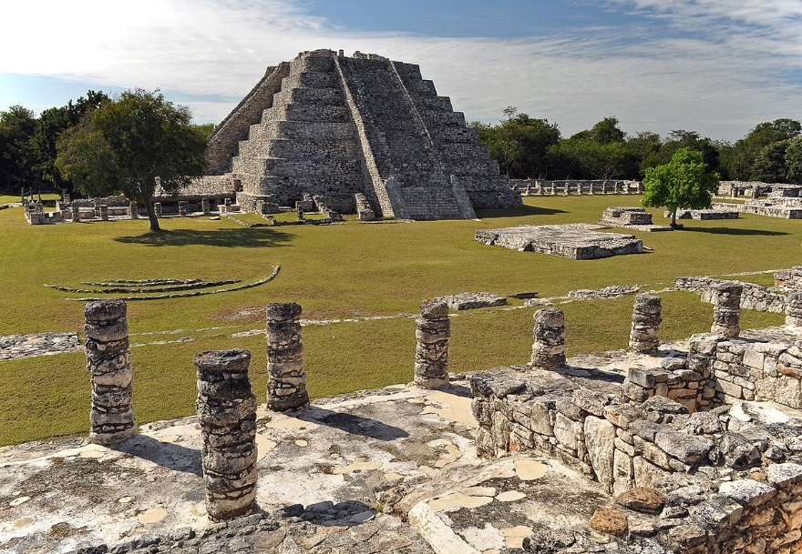

Art

This half term we will be designing to a specific criteria or specification, developing design ideas for a room interior, a coat of arms and product to fit a given name, children will learn to draw inspiration from different sources and use a range of techniques to experiment with their different concepts.

Science

Animals, including humans

To describe the changes as humans develop to old age.

Does the largest animal have the longest gestation period?

Puberty talk with the school nurse

Science enquiry skills

Using secondary sources of information

Pattern seeking

Close observational skills

PSHE

This half term we will be looking at the food choices we make and answering the following questions: Are we a healthy bunch? Which is the healthiest menu? What do we need to do to be healthier? Are all images we see in the media true?

We will also be looking at physical contact and answering the question how important is touch?

Music

In music the children are focussing on improving their keyboard skills and learning how to play the recorder. They will do this in a range of different ways and links will be made to the Mayans.

RE

What does it mean to be a Muslim in Britain today?

What is a special place for Muslims? Why are the 5 pillars of Islam important to Muslims? How does Shahadah affect the life of a Muslim?

Geography

In geography this half term we will be learning about biomes. We’re going to learn about aspects of physical geography. To do this we are going to use maps, atlases, globes, digital computer mapping to locate and describe the features we study.

Spanish

In Spanish this half term, we will be learning about the family. We will have conversations with each other using the new vocabulary that we have learnt. We will also draw on past learning to build longer sentences and conversations

PE

Indoor

Archery

Focussing on correct stance and body position, aim and strong arm position

Outdoor

Cricket

Focussing on batting technique – body position, placing of feet and keeping an eye on the ball.

Bowling technique – overarm bowling – arm positions, placing of feet, eye on the target