**Year 5**

Maths

In maths this term we will be learning to multiply and divide using short and long multiplication methods and short division methods. We will also be learning about fractions, including equivalent fractions, fractions of amounts, adding and subtracting fractions, converting between mixed numbers and improper fractions and multiplying fractions by integers.

This means we need to be very secure in our recall of times tables’ facts so this needs lots of practise at home.

English

This term in English, we will be writing a story based on the book ‘The Nowhere Emporium’. We will be using description to create our own mystery story about a store that can magically appear anywhere. We will also be writing a balanced argument on our screen use. We will write for and against arguments about the time that we spend on games and computers. We will be using a range of persuasive techniques to win the argument.

**Spring 1**

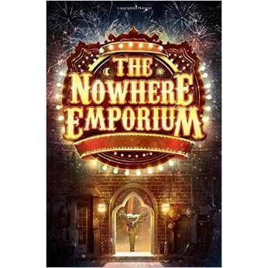

Music

In music, we will be learning to sing with increasing accuracy and expression. We will sing in several parts and improve our reading of standard notation.

PSHE

In PSHE this term, we will be talking about healthy lifestyles. We will be thinking about the three aspects of a healthy lifestyle: physical, emotional and mental health. We will be looking at how we can have a healthy lifestyle and who can help us.

PE

In indoor PE, we will be learning the Hakka as part of a dance unit. We will be creating our own dances and giving feedback to others as well as using feedback from others to improve our own performance.

In outdoor PE, we will be taking part in outdoor adventure activities. As part of these activities, we will learn how to work as a team, think creatively to find solutions to challenges in a quick and efficient way.

Spanish

This term in Spanish, we will be learning the numbers to fifteen. They will then be using this to answer the question ‘how old are you?’ This will be added to their conversational knowledge from the first term to create a small paragraph.

Art

This term we will be developing design, drawing, craft and art appreciation skills. The children will be creating an invention, expanding on an observational drawing, using a poem to create a portrait of themselves and painting an enlarged section of drawn collage.

Geography

In geography, we will be looking at where England is in the world. As a part of this topic, the children will start by learning about hemispheres, the equator, about both the north and south poles. The children will then learn about longitude and latitude using a world map to help them. They will explore time zones of countries all around and compare these to England. Lastly, the children will learn about the differences between tropical and Polar Regions.

RE

This term we will answering the big question, ‘If God is everywhere, why go to a place of worship?’ through studying how Christian, Jewish, Hindu and Muslim beliefs shape their different places of worship. We are hoping to be able to visit St Vincent’s Church and Cutgate Methodist Church.

Science

In science this term we will be studying the different properties of materials. We will be answering the following questions through a range of investigations:

* What properties do materials have in common?
* Which paper is the most transparent?
* Which paper is the most absorbent?
* Which material thermally insulates for the longest?

We will also be researching chemists and learning the technical scientific vocabulary of comparison, transparency, absorbency, thermal insulation, chemist, properties, thermal conduction, waterproof, opaque, translucent, rigid, flexible and elastic and what they all mean.