**Year 6**

English

For our final half term, we will continue with ‘The Secrets of the Sun King’ for our class novel. We will be looking at a range of question types while helping the children to use evidence to support their answers.

For our writing, we will be revisiting some previous units and supporting the children to edit and improve what the originally wrote. We will also have the opportunity to perform and compose poems.

The children will also have the opportunity to familiarise themselves with play scripts and the work of Shakespeare.

Maths

As we have covered all the units needed in Y6, we will spend the remaining term helping the children to be more confident by helping them to solve problems and apply their mathematical knowledge. We will continue to help the children develop their mental maths strategies and quick recall.

We will have the opportunity this term support children who may have found some of the curriculum difficult and cover any misconceptions that they have.

**Summer 2**

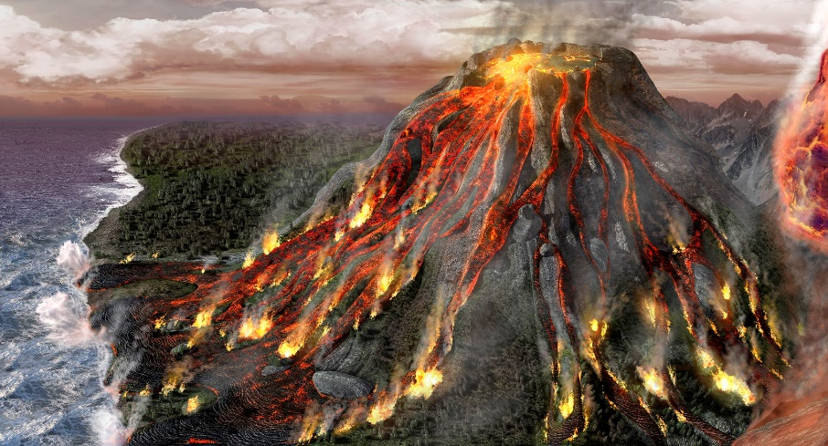

PSHE

Children will be learning the principles of enterprise and understanding profit and financial loss.

Children will learn ways to generate income and understand the principles of charity.

RE

Our final key question in RE is ‘What difference does it make to believe in Ahimsa (harmlessness), Grace, and Ummah (community)?’ Alongside this key question, the children will learn to evaluate life’s ‘Big Questions’ from the perspective of Christianity, Islam, Hinduism and non-religious views.

Music

This half term we will continue to use the keyboards. During the term, we will be learning composition and playing with two hands. We will be learning the background for, and recognise the tune of Ode to Joy.

PE

While continuing to discuss the importance of fitness and health, we will be learning how to play Ultimate Frisbee and compete in athletic activities. In our outdoor session, we will be learning about orientation; using map skills and team work.

Computing

This half term we will continue with spreadsheets – generating formula and manipulating cells.

We will also spend some time with coding, using Scratch software to make a game.

Art/DT

In art we will be looking at Landscapes can be warm or cool depending on the choice of colours while drawing images with perspective.

Earthquake shelter

History/Geography

Firstly, we will be completing our History unit on Ancient Egyptians, this will be looking at the importance of the Nile.

Lastly, in Geography we will be leaning about Volcanoes, Earthquakes and North America (including the different biomes and geographical features).

Science

Firstly, we will be completing our unit on classification. We will then learn about Living things and their habitats. We will learn about the importance of how things are classified based on observable characteristics, similarities and differences. This unit will consist of studying micro-organisms, plants and animals. The children will be encouraged to use reasoning for their own classifications of plants and animals while representing this in keys, tables, graphs and diagrams.