**Year 6**

English

This half term, our class novel will be ‘The Secrets of the Sun King’ by Emma Carroll. We will be using parts of the book to apply reading skills such as; inference, deduction, summarising, retrieving information from the text and understanding author’s use of language.

Our main writing genre this half term is explanation texts. We will also be reviewing and editing past independent writes.

Maths

In maths, we will be completing our unit on statistics which includes drawing pie charts and solving problems using the mean.

Within our arithmetic lessons, we will be consolidating the children’s understanding of the four operations and working with equivalent fractions, percentages and decimals.

Throughout the half term, we will also be revisiting previous units that the children were less confident with and exploring mathematical problems.

**Summer 1**

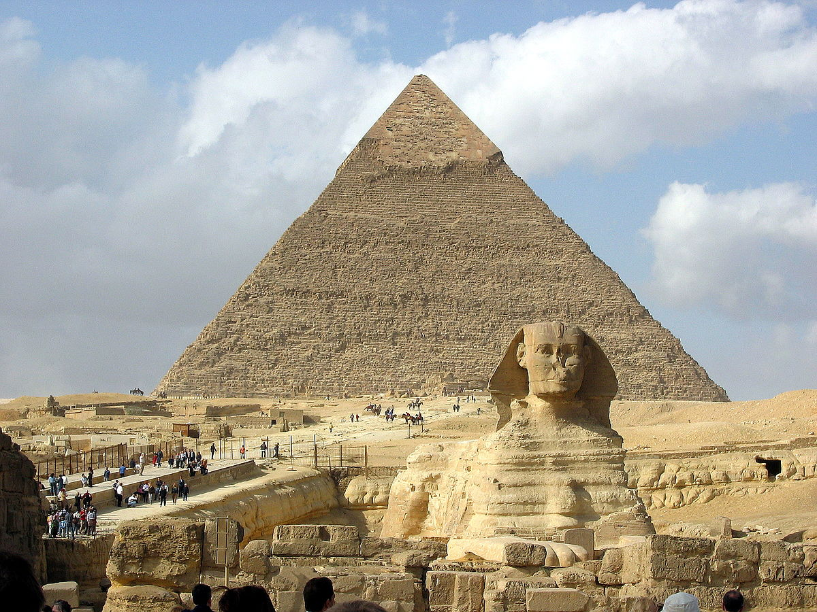

RE

This half term, the children will be answering the big question, ‘What matters most to Christians and Humanists?’ They will considering both perspectives while asking their own questions about what is important to them.

Art/DT

In this topic, pupils revisit their still life skills, creating a variety of pieces influenced by different artists and using a range of mediums. They will use charcoal, erasers and paint to depict their chosen composition of special objects before using them to construct a memory box to display their work.

PSHE

In PSHE, we will be helping the children to be more economically aware. This will be done through understanding a budget and how to stick to it, and understanding consumer needs.

Spanish

This half term, we are going to be learning the vocabulary for family. The children will be using the vocabulary within written sentences and oral conversation.

PE

This half term, the children will be developing their archery skills. They will be taught the correct stance, technique for shooting and working on accuracy.

For our outdoor sessions, the children will be learning the rules and game play for rounders. Children will learn the skills for batting and fielding.

History/Geography

Within our Geography lessons, we will be learning about Ancient Egypt. We will be exploring the answers to questions such as:

Who were the Egyptians and when did they live?

What can ancient artefacts tell us?

We will also be learning about Egyptian writing, hieroglyphics and how the Egyptians preserved their dead.

Science

Our topic this half term is ‘Living things and their habitats’. We will be looking at different ways to group and classify living things, including animals, plants and micro-organisms. The children will be able to classify a range of organisms by using observable features and create their own keys, and use Venn diagrams to sort these

They will relate classification to the work of Carl Linnaeus and recognise why classification is important and look at some examples from current science in the wider world which use classification.

Music

This half term, the children will be learning to play a simple melody on a keyboard, using two hands.

They will explore compositions on the keyboard and look at famous composers such as Beethoven.