**Year 6**

Maths

We will continue to practise skills and knowledge taught in lessons from the Autumn term on a daily basis. Arithmetic skills will be still be set for homework every week. Children will also be given key facts to learn which will greatly help them in their Y6 SATS. This term, we will be learning about, reading and writing decimals and applying our knowledge to the four operations. After decimals, we will develop our understanding of percentages. The children will learn how to find a percentage of an amount. They will order fractions, decimals and percentages using the concepts of equivalence.

English

Our first writing genre this half term will be an informal non-fiction case file, based on a character from our class read. Our class read will be The Falcon’s Malteaser by Anthony Horowitz. Using our class book as stimuli, we will also be completing a newspaper article.

Each week we will select appropriate spellings to learn and these will be sent home for homework, alongside other SPaG work. The children will continue to receive weekly reading comprehensions as part of their homework.

**Spring 1**

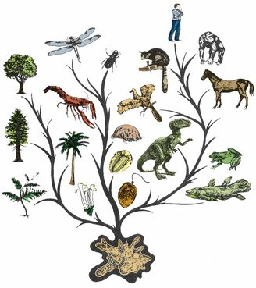

Computing

Computing this term will be implemented through other curriculum areas and specific units will be taught in Spring 2. We will however, be covering online safety throughout the year within PSHE.

Art/DT

This term we will be looking a sculpture and making our own inspired by the work of Rodin’s The Thinker, Gormley’s Another Place, Michelangelo’s David, Gillespie’s The Famine Memorial and Sean Hedges-Quinn’s Gracie Fields.

PE

This half term the children will begin their indoor sessions with volleyball. The children will learn the rules of the game develop skills and then apply these within games. Our outdoor unit will be developing leadership attributes and learning teamwork through football.

History/Geography

This term we will be determining what it is like in South America. We will begin by locating South America on the map and identifying significant facts. The children will research geographical features of South America while comparing its climate. Later in the half term, we will spend some time finding out about Lake Titicaca.

Spanish

This half term we will be focussing on securing the counting of numbers up to 15, reading, writing and spelling them accurately. We will then be able to use these numbers to ask about people’s ages and further develop our oral and written conversations.

Science

Our topic this half term is Evolution and adaptation. The children will be learning about how all animals and pants vary and how these variations are passed on to their offspring – the children will be looking at their own ancestors/families and trying to see which characteristics they may have inherited themselves.

We will be exploring how animals are adapted to their environments and researching the characteristics of animals and plants that live in hot places (deserts) and cold places (the arctic). How do their characteristics help them to survive?

We will the finally move onto looking at the work of Charles Darwin and how his discoveries and the fossil record give us evidence to support theories of evolution. We will also be thinking about the differences between natural selection and artificial selection (breeding).

PSHE

In our PSHE, we will reviewing our expectations in Y6 and the importance of resilience. Throughout this half term, we will be learning how to recognise early signs of illness and learning more about allergies, immunisations and vaccinations as part of our health unit.

Music

This half term, the children will be developing their skills in reading music and playing simple melodies on the keyboard. They will learn to play using both hands separately and then together.

RE

Our Big Question this half term is, ‘Is it better to express your religion in arts and architecture or in charity and generosity?’

We will seek to answer this question by learning about Christianity, Islam, Non-religious beliefs and hope to visit a place of worship.