**Year 6**

English

As we prepare for the SATs in May, we will be spending more time this half term practicing and consolidating our spelling, grammar and punctuation knowledge each week.

In our writing lessons, we will follow ‘The Write Stuff’ approach to writing a narrative on adventure and a persuasive piece linked to our Geography lessons.

In our reading, we will continue with our class read, ‘The Falcon’s Malteaser’ while providing the children with opportunities to answer a range of question types during comprehension lessons.

Maths

Our topics this half term will be finding areas and perimeters of rectangles, and areas of triangles and parallelograms. We will be then looking at calculating volume before moving onto work on ratio and proportion. After that, we will cover work on angles, measuring with protractors, and finding missing angles in triangles, quadrilaterals and polygons. The children will also draw shapes and create nets of 3D shapes. Our final topic is data: reading and creating line graphs and pie charts and working out averages (the mean).

As well as all this, in preparation for the SATs tests, we will continue to practise skills and knowledge taught previously on a daily basis. Arithmetic skills will be still be set for homework every week and children should continue to practice their key facts at home.

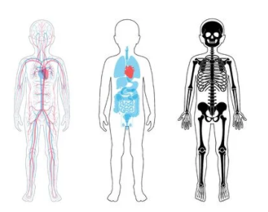**Spring 2**

Geography

The overarching question we will be thinking about is. ‘Are resources shared equally? How are local choices connected to global issues?’

We will start by looking at patterns of settlement and migration across the world, and then how people are linked by trade and economic activity in both developed and developing nations. Finally we finish by looking at sustainability and considering if we live in a fair world.

Science

This half term we will be learning about the human circulatory system and how to keep healthy.

We will start off by briefly revising work from Y3, on the skeleton and muscles, and from Y4, on the digestive system.

In our Y6 work, we will be finding out about blood vessels and the heart, and how blood is pumped around the body. We will be investigating how exercise affects our heart rate and learn how to measure this by finding our pulse.

Then will move onto how our lifestyles affect our health, and especially be thinking about how our diet, sleep, smoking and alcohol can affect people’s bodies.

PE

This half term, the children will develop leadership skills by coaching a younger year group through physical activities. For our indoor session, the children will develop balance, flexibility and equipment use through gymnastics.

RE

We will continue with our Big Question this half term, ‘Is it better to express your religion in arts and architecture or in charity and generosity?’

We will continue to explore different views and beliefs; including Christianity, Islam and a Non-religious view.

PSHE

During this term, we will be understanding more about mental health and how we can find ways to help if we have concerns or worries. The children will consider and discuss the impact of bullying and how to deal with transitions in life, including the move to High School.

Music

The children will be using ICT to compose music and will be looking at changes in musical styles through history.

Computing

The unit of work is Communication. The children will learn about the World Wide Web as a communication tool. They will learn how we find information on the World Wide Web, through learning how search engines work and what influences searching. They will also look at and evaluate different methods of internet communication, and consider how to use the internet safely as part of this.