**Year 1**

Maths

In maths, we shall be learning about numbers to 10. The children will be sorting, comparing numbers using < >, counting forwards/backwards, representing numbers to 10, counting 1 more or 1 less, ordering numbers and looking at a number line to 10 – we shall be very busy! Within this we shall be learning, with instant recall + facts up to and including 6. After this, we shall be learning how to = and – numbers to 10.

English

We will be focussing on set 1 and 2 sounds.

**Set 1:** m, a, s, d, t, I, n, p, g, o, c, k, u, b, f, e, l, h, sh, r, j, v, y, w, th, z, ch, qu,x, ng and ng.

**Set 2:** igh, ow, oo, oo, ar, or, air, oy, ir, ay, ou, ng and ee.

**Writing:**

In writing, the children will be listening to a range of stories. Whilst listening to the stories, the children will be discussing a range of words such as verbs and adjectives. These words will then help the children to create oral sentences.

**Reading:**

In our reading sessions, the children will reading, be listening to and discussing a range of ‘Traditional Stories’ such as: Sleeping Beauty, Puss-in-Boots and Pinocchio.

**Autumn 1**

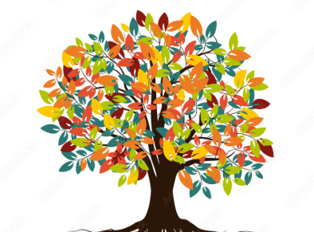

PE

During our outdoor PE lessons we will be practising fundamental movement skills using balls and other equipment. During our indoor PE lessons we will be improving our flexibility, strength and breathing to boost our physical and mental wellbeing through yoga.

2C PE sessions are on a Thursday and 1/2S PE sessions are on a Friday. Please ensure that your child has a PE kit in school. PE kit consists of black/navy shorts, a white t-shirt and black trainers/pumps.

DT

In our design and technology lessons, the children will be exploring mechanisms. We will be looking at ways to use mechanisms to make a moving monster puppet.

History

In history, we will be learning about the King and the Prime Minister and then explorers. We will look at Neil Armstrong and how he explored the moon and Ibn Battuta who explored Asia and Africa over 30 years.

RE

In RE we will be learning about who is Jewish and what they believe.

Science

In science, we will be learning about materials. We will be looking at everyday objects and the material from which they are made. We will be Identifying and naming a variety of everyday materials, including wood, plastic, glass, metal, water, and rock. We will describe the simple physical properties of a variety of everyday materials. We will compare and group together a variety of everyday materials on the basis of their simple physical properties

Music

In music we will be using instruments to represent animals, copying rhythms and creating call and response rhythms.

PSHE

Our focus for our PSHE lessons is relationships. We will be focusing on the importance of fairness, family and friends and communicating with others.

Computing - Coding

In computing, we will be learning about robot algorithms using the Bee-Bots. This unit develops the children’s understanding of instructions in sequences and the use of logical reasoning to predict outcomes.