**Year 1**

English

We will be focussing on set 1 and 2 sounds.

**Set 1:** m, a, s, d, t, I, n, p, g, o, c, k, u, b, f, e, l, h, sh, r, j, v, y, w, th, z, ch, qu,x, ng and ng.

**Set 2:** igh, ow, oo, oo, ar, or, air, oy, ir, ay, ou, ng and ee.

**Writing:**

In writing, the children will be listening to a range of stories from Rosie’s Walk to We’re Going on a Bear Hunt. Whilst listening to the stories the children will be discussing a range of words such as verbs and adjectives. The children will be given words such as luscious, scattered and emerald and their meanings will be discussed. Using these words as basis, the children will generate and write their own words. These words are then used to compose sentences using capital letters, finger spaces and full stops accurately.

**Reading:**

In our reading sessions, the children will reading, be listening to and discussing a range of ‘Traditional Stories’ such as: Sleeping Beauty, Rapunzel, Puss-in-Boots and Pinocchio.

Maths

In maths, we shall be learning about numbers to 10. The children will be sorting, comparing numbers using < >, counting forwards/backwards, representing numbers to 10, counting 1 more or 1 less, ordering numbers and looking at a number line to 10 – we shall be very busy! Within this we shall be learning, with instant recall + facts up to and including 6. After this, we shall be learning how to = and – numbers to 10.

**Autumn 1**



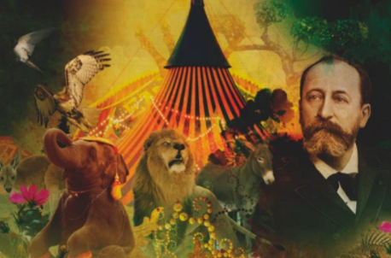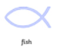

Science

In Science, we will be answering the question: What is it like around our school? We shall be exploring the plants and trees that grow around our school grounds and identifying what animals we see. The children will then focus on animals and humans in particular. They will compare and classify different types of animals.

RE

Our RE will focus upon the question: Who is a Christian and what do they believe? We shall be identifying the symbols that represent Christianity and looking at a Bible to learn about what it tells us about God and the importance of Jesus. We shall briefly reflect upon where God is.

Music

Music is taught by Mrs Drumm. The children shall be learning about, listening to, discussing and performing elements of music from the Carnival of the Animals. They will also learn about its talented composer Camille Saint-Saëns.

PE

In indoor PE, the children will be learning how to balance and hold simple yoga poses and outdoor PE the children will be walking, jumping forwards and backwards with improve control.

PSHE

This half term, we will helping the children to understand the importance of having rules and how they contribute to the expectations of school. We shall discuss what friendship is, why friends and making friends is important as well as good and bad characterises of a friendship.

Art

The children will start their Art lessons in year 1 by drawing lines, using mark making to draw water and exploring mark making through observational drawing. The children will then be able to apply their drawing skills to draw from observation themselves! In addition to this the children will be learning how to mix secondary colours from the primary colours. They will apply these colours to recreate their own version of work by the artist Jasper Johns and even paint their very own Clarice Cliff plates!

Geography

In Geography, the children will be learning to answer the question: How does the weather change across the year? During these lessons, the children will learn about the different seasons and in which months they occur. The children will learn about the different weather types and the weather symbols that correspond to this.

Computing

In computing, the children will be learning how to make a robot move! This will involve the children being able to programme a robot by pressing buttons and entering a set of simple directional instructions known as commands. The commands will include left, right, forward and back. Whilst programming, the children will need to plan and think of a route that they would like their robot to take.