**Year 1**

Maths

In maths, we shall be learning about numbers to 10. The children will be sorting, comparing numbers using < >, counting forwards/backwards, representing numbers to 10, counting 1 more or 1 less, ordering numbers and looking at a number line to 10 – we shall be very busy! Within this we shall be learning, with instant recall + facts up to and including 6. After this, we shall be learning how to = and – numbers to 10.

English

We will be focussing on set 1 and 2 sounds.

**Set 1:** m, a, s, d, t, I, n, p, g, o, c, k, u, b, f, e, l, h, sh, r, j, v, y, w, th, z, ch, qu,x, ng and ng.

**Set 2:** igh, ow, oo, oo, ar, or, air, oy, ir, ay, ou, ng and ee.

**Writing:**

All children will be building and holding sentences based upon what they have read. We are working upon using capital letters, fingers spaces and full stops.

**Reading:**

Reading is based upon the sounds that we are learning. We are now beginning to read more fluently using fred talk. (Sounding out). Words are split into red and green words. Green words you can fred talk but red words are a little more tricky.

**Autumn 1**

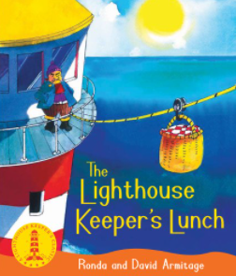

Art

The children will be drawing in Art, using pencils and applying different pressures to see what affects this has an the appearance of their art. In addition to this, they will be comparing drawings form memory and observations as well as drawing a person, drawing from their imagination and using colour for effect - colour in one direction and trying to colour within given lines.

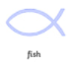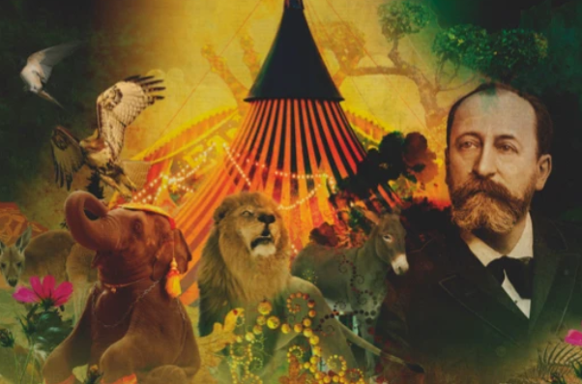

PE

In indoor PE, the children will be learning how to balance and hold simple yoga poses and outdoor PE the children will be walking, jumping forwards and backwards with improve control.

Computing

In computing, we shall be discussing and learning about the importance of E safety. What can we do to stay safe online, what is E safety and why it is so important to stay safe when using the internet, no matter what devise is being used. The children will also use a computer to log in safely, start to understand the idea of ‘ownership’ of their creative work, learn how to find saved work in the Online Work area and find teacher comments.

To learn how to search Purple Mash to find resources.

To become familiar with the types of resources available in the Topics section.

To become more familiar with the icons used in the resources in the Topics section.

To start to add pictures and text to work.

To explore the Tools section of Purple Mash and to learn about the common icons used in Purple Mash for Save, Print, Open, New.

* To explore the Games section on Purple Mash. -To understand the importance of logging out when they have finished.

Book Study

Reading and a love for reading is so important for all children! To help kick start our love for reading in year 1, the children are going to read The Lighthouse Keepers Lunch by Ronda and David Armitage. Together we shall identify the main characters, make predictions about what might happen, describe the setting of the story retell the story through drama, write a brief book review and create our own Lighthouse Keepers Lunch menu! How exciting!

Science

In Science, we will be learning about everyday objects and their materials. The children will be identifying the difference between an object and the material it is made from. This will include naming everyday materials and discussing what both their purposes and properties are. Our final lesson in this unit will involve the children comparing properties of materials and grouping the objects

PSHE

This half term, we will helping the children to understand the importance of having rules and how they contribute to the expectations of school. We shall discuss what friendship is, why friends and making friends is important as well as good and bad characterises of a friendship.

RE

Our RE will focus upon the question: Who is a Christian and what do they believe? We shall be identifying the symbols that represent Christianity and looking at a Bible to learn about what it tells us about God and the importance of Jesus. We shall briefly reflect upon where God is.

Music

Music is taught by Mrs Drumm. The children shall be learning about, listening to, discussing and performing elements of music from the Carnival of the Animals. They will also learn about its talented composer Camille Saint-Saëns.