**Year 1**

English

The children will be progressing on their phonics journey and will continue to learn 1 and 2 sounds.

**Set 1:** m, a, s, d, t, I, n, p, g, o, c, k, u, b, f, e, l, h, sh, r, j, v, y, w, th, z, ch, qu,x, ng and ng.

**Set 2:** igh, ow, oo, oo, ar, or, air, oy, ir, ay, ou, ng and ee.

**Writing:**

All children will be building and holding sentences based upon what they have read. We are working upon using capital letters, fingers spaces and full stops.

**Reading:**

Reading is based upon the sounds that we are learning. We are now beginning to read more fluently using fred talk. (Sounding out). Words are split into red and green words. Green words you can fred talk but red words are a little more tricky.

Maths

In maths, we will continue to learn how to add and subtract 10. We will then extend our numbers to 20. The children will be, comparing numbers using < >, counting forwards/backwards, representing numbers to 20, counting 1 more or 1 less and ordering numbers. After all of this, the children will learn about 2D and 3D shapes. The children will be recognising and naming them, sorting 2D and 3D shapes in addition to working with shape patterns.

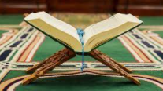**Autumn 2**

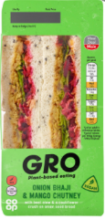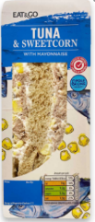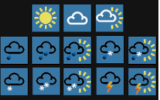

Music

This term in music the theme is ‘Toys of the past’. The children will learn about Mozart’s Toy Symphony and begin to choose instruments for effect.

PSHE

In PSCE, the children will be learning about the importance of manners no matter where they are. We will talk about what positive choices are and how these can lead to happiness. Alongside this feeling, we will discuss anger, how to manage it and express this in a positive way.

RE

Our RE will focus upon the question: What are the main beliefs in Islam? The children will begin by identifying who is important to them and why. We shall then discuss why Allah and the Prophet Mohammed are important to Muslims. The children will learn about the five pillars of faith and their names as well as looking at a Quran and explaining why this is important to Muslims.

Science

In Science, we will be discuss the weather by watching weather forecasts, understanding the symbols that forecasters use, and look at wind speed and begin to observe the weather conditions daily. We will identify how the Autumn seasons weather changes in addition to creating shadows and learning how shadows change their appearance.

History

We shall start off the unit of work by discussing what toys are and what the features of modern day toys are. We will then be looking at ‘old’ toys and comparing them to the ones of the modern day. Why have the toys changed so much, why are the materials different? Who would play with the toys? We shall look at the chronology of toys too.

PE

In indoor PE, the children will be continuing to balance but this time through gymnastics. They will balance on points and patches. In outdoor PE the children throwing and rolling a ball underarm.

DT

Food! We will begin our DT unit by understanding what foods are healthy and develop ideas for a healthy sandwich. Then we will evaluate a range of ready-made sandwiches. From this, the children will design and make their own healthy sandwich – for this, they will be writing their own instructions too! The unit of work will end with the children evaluating their own healthy sandwiches.

Computing

In this unit of work, the children will begin to program animations using a computer programme called ‘Scratch Junior’. They will explore the way a project looks by investigating sprites and backgrounds. They will use programming blocks to use, modify, and create programs. Learners will also be introduced to the early stages of program design through the introduction of algorithms.