**Year 2**

Maths

In Maths, we will be counting, reading and ordering numbers to 100. We will be using mental strategies to add and subtract and solve number problems. We will be learning how to multiply and divide as well so please help your child learn by heart the 2 5 and 10 times table and the division facts related to each multiplication. We will also be learning to recognise coins as well as adding totals of money and finding change.

English

**Reading** - We follow the RWI programme. The RWI programme teaches children how to read accurately and fluently, with good comprehension. Children will have their reading books changed on a **Friday**. Please ensure that your child has their reading books and reading record in school every day.

**Writing** - We practise our handwriting, learning correct letter formation and how to join letters regularly. Using ‘The Write Stuff’ writing approach, children will be learning how to write a narrative based on ‘The Queen’s Hat’, and a non-fiction interview text based on Neil Armstrong.

**Autumn 1**

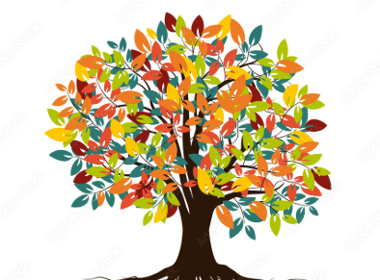

History

In history, we will be learning about the King and the Prime Minister and then explorers. We will look at Neil Armstrong and how he explored the moon and Ibn Battuta who explored Asia and Africa over 30 years.

RE

In RE we will be learning about who is Jewish and what they believe.

DT

In our design and technology lessons, the children will be exploring mechanisms. We will be looking at ways to use mechanisms to make a moving monster puppet.

PE

During our outdoor PE lessons we will be practising fundamental movement skills using balls and other equipment. During our indoor PE lessons we will be improving our flexibility, strength and breathing to boost our physical and mental wellbeing through yoga.

2C PE sessions are on a Thursday and 1/2S PE sessions are on a Friday. Please ensure that your child has a PE kit in school. PE kit consists of black/navy shorts, a white t-shirt and black trainers/pumps.

Science

In science, we will be learning about materials. We will be looking at everyday objects and the material from which they are made. We will be Identifying and naming a variety of everyday materials, including wood, plastic, glass, metal, water, and rock. We will describe the simple physical properties of a variety of everyday materials. We will compare and group together a variety of everyday materials on the basis of their simple physical properties

Music

In music we will be using instruments to represent animals, copying rhythms and creating call and response rhythms.

PSHE

Our focus for our PSHE lessons is relationships. We will be focusing on the importance of fairness, family and friends and communicating with others.

Computing - Coding

In computing, we will be learning about robot algorithms using the Bee-Bots. This unit develops the children’s understanding of instructions in sequences and the use of logical reasoning to predict outcomes.