**Year 2**

Maths

In Maths, we will be counting, reading and ordering numbers to 100. We will be using mental strategies to add and subtract and solve number problems. We will be learning how to multiply and divide as well so please help your child learn by heart the 2 5 and 10 times table and the division facts related to each multiplication. We will also be learning to recognise coins as well as adding totals of money and finding change.

English

As part of our English lessons, we follow the RWI programme. The RWI programme teaches children how to read accurately and fluently, with good comprehension. We practise our handwriting daily, learning correct letter formation and how to join letters.

We also use the writing approach ‘The Write Stuff’. Children will be learning how to write a narrative based on ‘The Owl who was Afraid of the Dark’, and a poem based on ‘If I were in Charge’.

Children will have their reading books changed on a **Friday**. Please ensure that your child has their reading books and reading record in school every day.

**Autumn 1**

RE

In RE we will be learning about who is Jewish and what they believe.

History

In history, we will be learning about how Gracie Fields and the Co-op are important to our local area.

DT

In our design and technology lessons, the children will be exploring mechanisms. We will be looking at ways to use mechanisms to make a moving monster puppet.

PE

During our outdoor PE lessons we will be practising fundamental movement skills using balls and other equipment. During our indoor PE lessons we will be improving our flexibility, strength and breathing to boost our physical and mental wellbeing through yoga.

Outdoor PE sessions are on a Thursday and indoor PE sessions are on a Friday. Please ensure that your child has a PE kit in school. PE kit consists of black/navy shorts, a white t-shirt and black trainers/pumps.

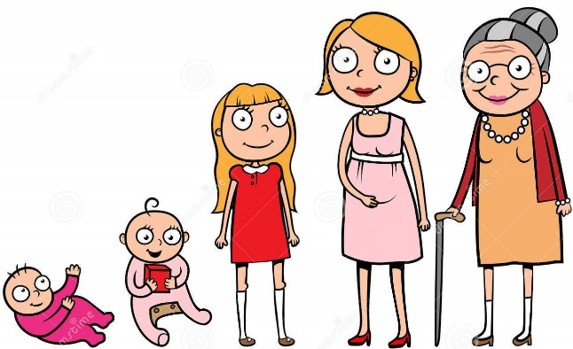

Science

In science, we will be learning about animals including humans. We will be learning about how humans and animals grow and change; match baby and adult animals, identify the basic needs of animals and humans, understand the importance of exercise and the effects it has on the human body and understand the importance of hygiene.

Music

In music we will be learning about rhythm and standard notation by playing the percussion instrument claves to produce different sounds.

PSHE

Our focus for our PSHE lessons is relationships. We will be focusing on the importance of fairness, family and friends and communicating with others.

Computing - Coding

In computing, we will be learning about robot algorithms using the Bee-Bots. This unit develops the children’s understanding of instructions in sequences and the use of logical reasoning to predict outcomes.