**Year 2**

English

As part of our English lessons, we follow the RWI programme. The RWI programme teaches children how to read accurately and fluently, with good comprehension. In writing, we rehearse out loud what we want to say. We practise our handwriting daily, learning correct letter formation and how to join letters. We develop our writing ideas, vocabulary and grammar by drawing on our own experiences and talking about the stories we have read.

**2BM** will have their reading books changed on a **Friday** and **2P** will have their reading books changed on a **Monday**. Please ensure that your child has their reading books and reading record in school every day.

Maths

In Maths, we will be counting, reading and ordering numbers to 100. We will be using mental strategies to add and subtract and solve number problems. We will be learning how to multiply and divide as well so please help your child learn by heart the 2 5 and 10 times table and the division facts related to each multiplication . We will also be learning to recognise coins as well as adding totals of money and finding change.

**Autumn 1**

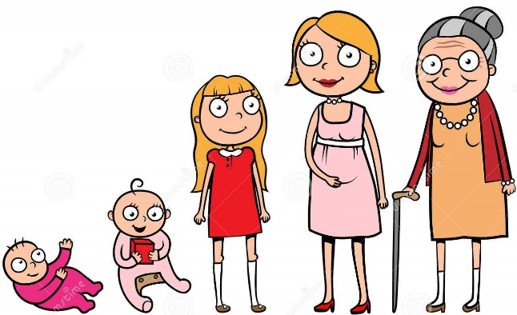

DT

Our DT topic is moving pictures. We will be sharing traditional stories together then create a moving picture using levers and sliding mechanisms.

PE

During our outdoor PE lessons we will be practising fundamental movement skills using balls and other equipment. During our indoor PE lessons we will be improving our flexibility, strength and breathing to boost our physical and mental wellbeing through yoga.

Outdoor PE sessions are on a Thursday and indoor PE sessions are on a Friday. Please ensure that your child has a PE kit in school. PE kit consists of black/navy shorts, a white t-shirt and black trainers/pumps.

PSHE

Our focus for our PSHE lessons is relationships. We will be focusing on the importance of fairness, family and friends and communicating with others.

Science

In science, we will be learning about animals including humans. We will be learning about how humans and animals grow and change; match baby and adult animals, identify the basic needs of animals and humans, understand the importance of exercise and the effects it has on the human body and understand the importance of hygiene.

Book Study

We will be reading the story ‘Amazing Grace’ by Mary Hoffman. Over the half term we will be completing lots of activities based around the story to develop our awareness of diversity, cultural differences and acceptance.

RE

In RE we will be learning about Christians and Jews and what they believe.

Extra Phonics

Due to lockdown, the 2021 Phonics Screen Check for Year 1 children did not take place. Therefore children who are now in Year 2 will complete the Phonics Screen Check in the second half of the autumn term. Extra phonics sessions will be delivered in order to plug gaps in the children’s phonics knowledge as well as prepare them for the Phonics Screen Check. Parent workshops will commence later in the term. More details to follow soon.

Music

In music we will be learning about rhythm and standard notation by playing the percussion instrument claves to produce different sounds.