**Year 2**

Maths

In maths we will be continuing to develop our addition and subtraction skills by adding and subtracting two 2 digit numbers using the column method. We will then use this knowledge and apply it to money. We will be learning how to count money in notes, pounds and pence; select money to make amounts, compare amounts of money; find totals and change as well as solving two-step word problems. Later on in the term we will move on to multiplication by learning how to recognise, make and add equal groups; complete multiplication calculations; use arrays and practise our 2x, 5x and 10x tables.

Don’t forget to log on to Numbots and TT Rockstars to practise your number bonds and times tables!

English

As part of our English lessons, we follow the RWI programme. The RWI programme teaches children how to read accurately and fluently, with good comprehension. In writing, we rehearse out loud what we want to say. We practise our handwriting daily, learning correct letter formation and how to join letters. We develop our writing ideas, vocabulary and grammar by drawing on our own experiences and talking about the stories we have read.

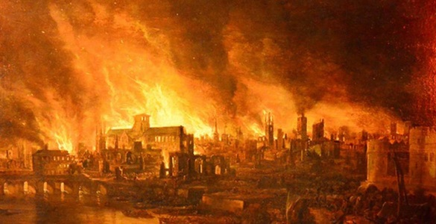**Autumn 2**

Art

In our art lessons we will be developing our drawing skills. We will be learning how to use a variety of drawing tools with consistency and control, learn how to sketch, draw repeating patterns and draw a self-portrait. We will be studying the work of Vincent Van Gogh and Anni Albers.

PE

In our indoor PE sessions this half term we will be learning and performing animal dances. In our outdoor PE sessions, we will be learning how to play target games and compete in teams.

PSHE

In PSHE we will be learning about the importance of relationships and the wider world. We will be learning about fairness; right and wrong; friendships; aspirations and co-operation.

History

Our history topic this half term is all about The Great Fire of London. We will be learning about how the fire broke out, ordering the main events during the fire in chronological order using a timeline, why the fire burned down so many houses, what could have been done to stop the fire and what happened to life as a result of the fire.

Computing

In computing we will be learning about the importance of internet safety and effective searching.

Music

In music we will be learning to sing a variety of songs about the Great Fire of London. Why not search for some songs on YouTube and practise singing them at home?

RE

In RE we will be learning about sacred books in world religions. We will be learning about which religious stories are important and why, why the Bible is important to Christians and how Christians live by the teachings of the Bible.

Science

In our science lessons will be learning about everyday materials and their uses. We will be learning to identify and name a variety of everyday materials including wood, plastic, glass, metal, water, and rock; describe the simple physical properties of a variety of everyday materials and compare and group together a variety of everyday materials on the basis of their simple physical properties.