**Year 2**

Maths

In Maths, we will be counting, reading and ordering numbers to 100. We will be using mental strategies to add and subtract and solve number problems. We will be learning how to multiply and divide as well so please help your child learn by heart the 2 5 and 10 times table and the division facts related to each multiplication. We will also be learning to recognise coins as well as adding totals of money and finding change.

English

As part of our English lessons, we follow the RWI programme. The RWI programme teaches children how to read accurately and fluently, with good comprehension. In writing, we rehearse out loud what we want to say. We practise our handwriting daily, learning correct letter formation and how to join letters. We develop our writing ideas, vocabulary and grammar by drawing on our own experiences and talking about the stories we have read.

Children will have their reading books changed on a **Friday**. Please ensure that your child has their reading books and reading record in school every day.

**Autumn 1**

Geography

In Geography we will be learning about the seven continents. We will learn about what a continent is, to name and locate the continents and oceans on a world map; locate the UK and identify its capital cities and surrounding seas. We will be having a visit from the Freshwater Theatre Company who will be delivering us a workshop about continents and oceans.

DT

Our DT topic is to explore wheel mechanisms and design a wheel. We will look at items which have wheels and then design our own wheel and axel to create a Ferris wheel.

PE

During our outdoor PE lessons we will be practising fundamental movement skills using balls and other equipment. During our indoor PE lessons we will be improving our flexibility, strength and breathing to boost our physical and mental wellbeing through yoga.

Outdoor PE sessions are on a Thursday and indoor PE sessions are on a Friday. Please ensure that your child has a PE kit in school. PE kit consists of black/navy shorts, a white t-shirt and black trainers/pumps.

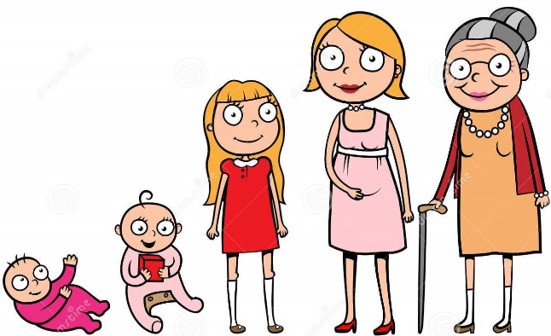

Music

In music we will be learning about rhythm and standard notation by playing the percussion instrument claves to produce different sounds.

PSHE

Our focus for our PSHE lessons is relationships. We will be focusing on the importance of fairness, family and friends and communicating with others.

RE

In RE we will be learning about who is Jewish and what they believe.

Computing - Algorithms

This unit develops children’s’ understanding of instructions in sequences and the use of logical reasoning to predict outcomes. They will design algorithms and then test those algorithms as programs and debug them.

Science

In science, we will be learning about animals including humans. We will be learning about how humans and animals grow and change; match baby and adult animals, identify the basic needs of animals and humans, understand the importance of exercise and the effects it has on the human body and understand the importance of hygiene.