**Year 2**

English

As part of our English lessons, we follow the RWI programme. The RWI programme teaches children how to read accurately and fluently, with good comprehension. In writing, we rehearse out loud what we want to say. We practise our handwriting daily, learning correct letter formation and how to join letters. We develop our writing ideas, vocabulary and grammar by drawing on our own experiences and talking about the stories we have read.

Maths

In Maths we will be learning about multiplication and division, statistics, geometry (shape), fractions and length and height. In our multiplication and division lessons we will be learning how to share and group; use arrays; make doubles; multiply and divide by 2, 5, and 10 and recognise odd and even numbers. In our statistics lessons we will be learning to make tally charts, and interpret and draw pictograms and block diagrams. In our shape lessons we will be recognising and naming the properties of 2D and 3D shapes; identify lines of symmetry and make patterns with 2D and 3D shapes. In our fractions lessons we will be recognising and finding a half, a quarter and a third.

**Spring 1**

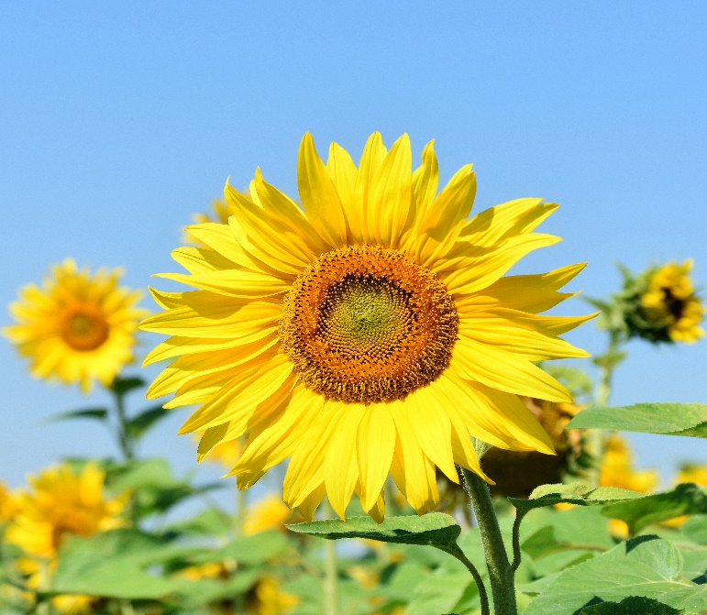

PSHE

Our focus for our PSHE lessons is health and wellbeing. We will be learning about healthy lifestyles, the importance of hygiene, how we change and grow; and the importance of keeping safe.

DT

In DT we will be learning about structures. Using the tale of Goldilocks and the Three Bears as inspiration, the children will help poor Baby Bear by making him a brand new chair. They will explore stability, investigate strengthen materials, make a new chair and test its stability.

RE

In RE we will be learning about how and why we celebrate special and sacred times. We will be discussing which times are special and why, why festivals are important to religious communities, how our beliefs can be expressed through art and charity as well as how we can express our spirituality through art.

Computing

In In this term we will look at information technology at school and beyond, in settings such as shops, hospitals, and libraries. We will investigate how information technology improves our world, and they will learn about using information technology responsibly.

History

In History we will be learning about the Royal Family. We will be plotting the Royal Family Tree and learning about the role of the King. We will looking at the difference between the King and the Prime Minister.

Music

In music, we will be learning about pitch and the diatonic scale using boomwhackers.

PE

In our indoor PE sessions, our focus is gymnastics. In our outdoor PE sessions, we will be participating in invasion games.

Science

In Science we will be learning about plants. We will name the parts of trees and plants and record what we see. We will be planting bulbs and seeds, learning about what they need to be able to grow well. We will observe and measure how much they grow each week and record this in a table then use the information to make a graph. We will also be setting up an experiment to observe how seeds grow in different conditions, then make a prediction about which seed will grow best and why. We will learn about the life cycle of a plant and how a seed changes and grows over time. We will learn that plants give us food to eat and which parts of the plant that these foods come from.

Why not try planting some seeds at home and see what flowers, fruits or vegetables you can grow?