**Year 2**

Maths

Our mathematical focus this half term is multiplication and division. We will be learning to recognise, make and add equal groups; use arrays and multiply and divide by 2, 5 and 10.

We will then move on to length and height. The children will learn how to measure in cm and m, compare and order lengths and heights and use the four operations with lengths and heights.

English

We will continue with our RWI phonics programme as well as the writing approach ‘The Write Stuff’. Children will be learning how to write a persuasive letter, and a poem based on Desk Diddler and The Day the Crayons Quit. We will be introducing the children to the Accelerated Reader programme where they can access a wider range of both paper and electronic books.

**Spring 2**

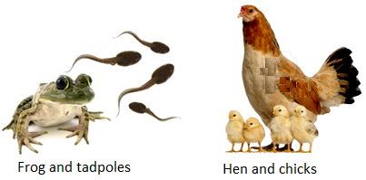

Science

We will be looking at what animals (including humans) must do in order to keep their bodies healthy. We will also carry out investigations into body parts such as “Do taller people have bigger feet?”

After this, we will start to look at the offspring of different animals. We may even get the chance to look at some tadpoles in our newly regenerated pond, thank you to Reception class!

Computing

We will be learning about pictograms. Children will begin to understand what the term data means and how data can be collected in the form of a tally chart. They will learn the term ‘attribute’ and use this to help them organise data. They will then progress onto presenting data in the form of pictograms.

RE

We will continue to learn about the importance of how and why we celebrate special and sacred in Christianity and Judaism.

Music

In music we will be learning about standard notation and learning how to play the glockenspiel.

Geography

This half term we will be studying where we live. Children will extend their knowledge of the local area around school. They will learn the difference between a village, town and city and draw simple maps.

PE

Our indoor PE lessons will focus on us using our bodies to create shape, movements and actions through dance. Our outdoor PE lessons will focus on jumping in a variety of ways and throwing with good technique in athletics.

Art

This half term we will be painting with mixed media. The children will be naming and mixing the primary and secondary colours, experimenting with different textures and selecting these to collage and then evaluate their work.

PSHE

Our PSHE focus is health and wellbeing. We will be naming the different parts of the body and learning about how our bodies change as they grow.