**Year 2**

English

We will continue with our RWI phonics and comprehension programme as well as the writing approach ‘The Write Stuff’. Children will be learning how to write a set of instructions for how to make a bird feeder. We will be introducing more children to the Accelerated Reader programme where they can access a wider range of both paper and electronic books.

Maths

Our mathematical focus this half term is multiplication and division. We will be learning to recognise, make and add equal groups; use arrays and multiply and divide by 2, 5 and 10.

We will then move on to length and height. The children will learn how to measure in cm and m, compare and order lengths and heights and use the four operations with lengths and heights.

**Spring 2**

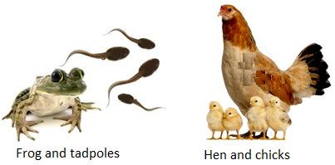

Music

In music we will be learning about Sorcerer’s Apprentice by Dukas. We will learn about the story and musical elements and use correct terminology to describe it.

Computing

We will continue to look at coding using an app called Scratch. This unit recaps from using Scratch Junior in year one. Children will begin to understand that sequences of commands have an outcome and will make predictions based on their learning. They will then use and modify designs to make their own quiz questions.

RE

We will continue to learn about the importance of how and why we celebrate special and sacred times in Christianity and Judaism.

PSHE

Our PSHE focus is health and wellbeing. We will be naming the different parts of the body and learning about how our bodies change as they grow.

Science

We will be continuing our work on plants then start looking at what animals (including humans) must do in order to keep their bodies healthy. We will also carry out investigations into body parts such as “Do older people have bigger hands?”

After this, we will start to look at the offspring of different animals.

Geography

This half term we will be studying where we live. Children will extend their knowledge of the local area around school. They will learn the difference between a village, town and city and draw simple maps.

PE

Our indoor PE lessons will focus on us using our bodies to create shape, movements and actions through dance. Our outdoor PE lessons will focus on jumping in a variety of ways and throwing with good technique in athletics.

Art

This half term we will be painting with mixed media. The children will be naming and mixing the primary and secondary colours, experimenting with different textures and selecting these to collage and then evaluate their work.