**Year 2**

English

We will continue with our new writing approach ‘The Write Stuff’. Children will be learning how to write a story based on the book ‘The Owl Who Was Afraid of the Dark’ by Jill Tomlinson. They will also be learning about the features of a non-fiction text by learning how to write a set of instructions for how to make a bird feeder. In preparation for Key Stage 2, we will be introducing the children to the Accelerated Reader programme where they can access a wider range of both paper and electronic books.

Maths

In Maths we will use mathematical vocabulary to describe position, direction and movement including movement in a straight line and distinguishing between rotation as a turn and in terms of right angles for quarter, half and three-quarter turns. We will be learning to tell and write the time to five minutes, including quarter past/to the hour and draw the hands on a clock face to show these times. We will learn how many minutes there are in an hour and the number of hours in a day.

**Summer 1**

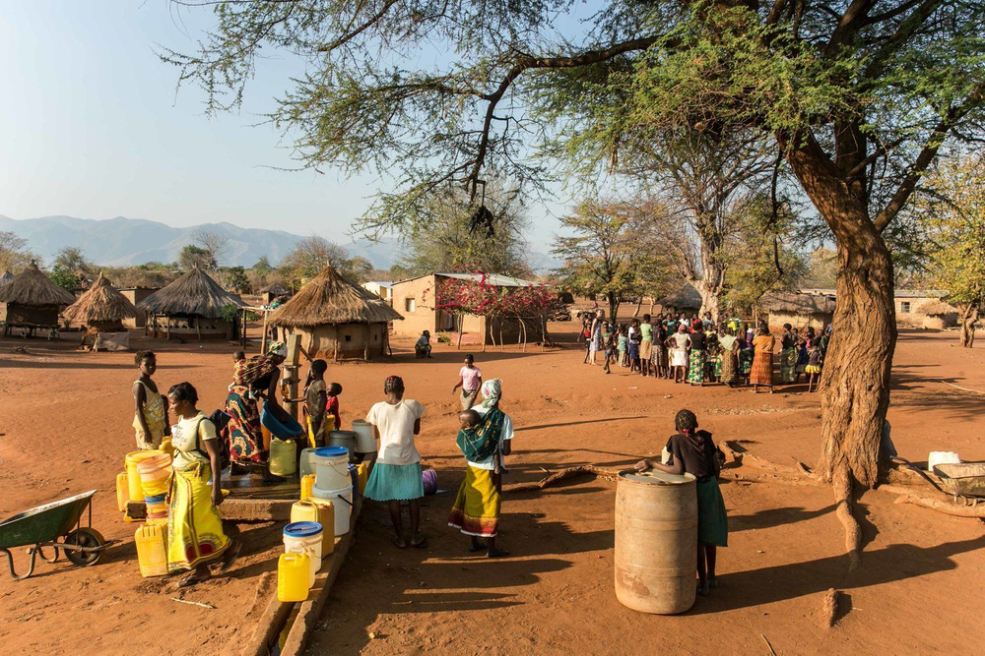

Science

In Science we will be learning about living things and their habitats.

We will spend our first science lesson identifying the differences between something that is dead or alive. By exploring outside, and through observation, we will look at the differences between things that are living, dead, and have never been alive. We will then explore the school grounds on the hunt for microhabitats and draw or photograph what is going on there. We will be researching creatures in larger habitats and ask ourselves: why do these living things live there? We will then draw on our understanding of microhabitats to design and make a bug hotel to encourage a variety of creatures into our school environment!

DT

In our design and technology lessons the children will be exploring mechanisms. We will be looking at ways to use mechanisms to make a moving monster puppet.

Computing

In computing we will be learning about how to create digital pictures. The children will learn to recognise that different devices can be used to capture photographs and will gain experience capturing, editing, and improving photos. Finally, they will use this knowledge to recognise that images they see may not be real.

RE

We will be learning about how different religions care for other people and for the world. Through studying Bible stories, the lives of believers such as Dr Barnardo, Mother Teresa, the Jewish practice of Tzedakah and Sukkot celebrations, pupils learn about how beliefs turn into actions for many religious and non-religious people.

PSHE

Our focus for our PSHE lessons is relationships. We will be learning about bullying and what to do if we or someone we know is being bullied. We will be learning about the importance of families caring for each other as well as recognising how our behaviour and actions can affect others.

Music

In music, we will be developing our singing voices by singing with expression and accuracy.

PE

In our indoor PE sessions, we will be continuing to develop our gymnastic skills of spinning, turning and twisting. In our outdoor PE sessions, we will be developing our catching and throwing skills by taking part in net and wall games.

Geography

In geography we will be studying the country of Zambia in Africa and comparing the village of Mugurameno to where we live in Rochdale.