**Year 2**

English

As part of our English lessons, we follow the RWI programme. The RWI programme teaches children how to read accurately and fluently, with good comprehension.

We also use the writing approach ‘The Write Stuff’. Children will be learning how to write a narrative based on ‘The Queen’s Hat’, and a recount based on Neil Armstrong.

Children will have their reading books changed on a **Friday**. Please ensure that your child has their reading books and reading record in school every day.

Maths

In Maths we will be learning about multiplication and division, statistics, geometry (shape), fractions and length and height. In our multiplication and division lessons we will be learning how to share and group; use arrays; make doubles; multiply and divide by 2, 5, and 10 and recognise odd and even numbers. In our statistics lessons we will be learning to make tally charts, and interpret and draw pictograms and block diagrams. In our shape lessons we will be recognising and naming the properties of 2D and 3D shapes; identify lines of symmetry and make patterns with 2D and 3D shapes. In our fractions lessons we will be recognising and finding a half, a quarter and a third.

**Spring 1**

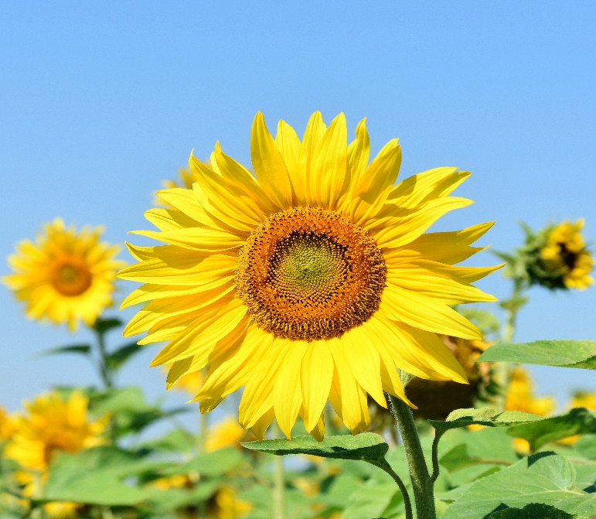

PSHE

Our focus for our PSHE lessons is health and wellbeing. We will be learning about healthy lifestyles, the importance of hygiene, how we change and grow; and the importance of keeping safe.

DT

In DT we will be learning about structures. Using the tale of Goldilocks and the Three Bears as inspiration, the children will help poor Baby Bear by making him a brand new chair. They will explore stability, investigate strengthen materials, make a new chair and test its stability.

RE

In RE we will be learning about how and why we celebrate special and sacred times. We will be discussing which times are special and why, why festivals are important to religious communities, how our beliefs can be expressed through art and charity as well as how we can express our spirituality through art.

Computing

In In this term we will look at coding using an app called Scratch. This unit recaps from using Scratch Junior in year one. Children will begin to understand that sequences of commands have an outcome and will make predictions based on their learning. They will then use and modify designs to make their own quiz questions.

PE

In our indoor PE sessions, our focus is gymnastics. In our outdoor PE sessions, we will be participating in invasion games.

Science

In Science we will be learning about plants. We will name the parts of trees and plants and record what we see. We will be planting bulbs and seeds, learning about what they need to be able to grow well. We will observe and measure how much they grow each week and record this in a table then use the information to make a graph. We will also be setting up an experiment to observe how seeds grow in different conditions, then make a prediction about which seed will grow best and why. We will learn about the life cycle of a plant and how a seed changes and grows over time. We will learn that plants give us food to eat and which parts of the plant that these foods come from.

Why not try planting some seeds at home and see what flowers, fruits or vegetables you can grow?

Geography

This half term we will be studying where we live. Children will extend their knowledge of the local area around school. They will learn the difference between a village, town and city and draw simple maps.

Music

In music, we will be learning about pitch and the diatonic scale using boomwhackers.