**Year 3**

Maths

Place value

Representing numbers

Looking at ones, tens and one hundreds.

Representing numbers through images.

Addition and Subtraction

Looking at strategies to help us to solve addition calculations.

Multiplication and Division

Introduction to TTRockstars and timestables battles.

Learning our 3 times tables including division facts.

Looking at strategies to help us to solve multiplication and division calculations.

English

Reading

An introduction to Myon,

An investigation into new vocabulary, looking at features of fiction and non-fiiction texts and answering basic comprehension questions.

Class read – George’s marvellous medicine.

This book will be read by the teaching team so the children can enjoy being read to. We will discuss features of the text and ambitious language.

Writing

We will be revisiting basic sentence structures including basic punctuation.

Fiction – The Real story of the three little pigs.

Non- fiction report writing about Robodog, a mechanical animal.

**Autumn 1**

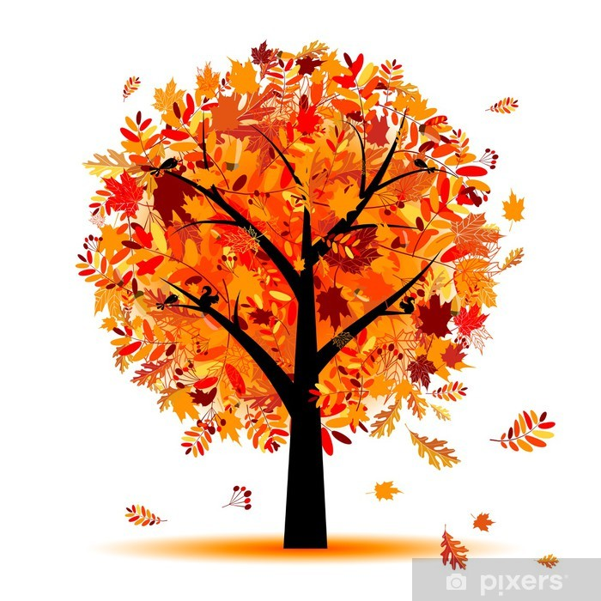

PSHE

Classroom rules- how to be kind, respectful and show responsibility for ourselves, others and our belongings.

E-safety – how to behave safely

whilst online and not sharing personal information.

DT

DT- We will be making fruit kebabs. Investigating where certain fruits come from, We will design and create our own fruit kebabs. We will taste them then evaluate what we make to identify any amendments or improvements we may like to make.

RE

We will be asking ourselves ‘What do different people believe about God?’ We will be investigating Christian beliefs and Muslim beliefs. We will then compare similarities and differences.

PE

Health Related Fitness

We will explain why it is important to warm-up

Identify some muscle groups used in a particular action e.g. throwing

We will be practising basic skills and athletics.

Science

Animals including humans (animal nutrition, skeletons and muscles).

To find out what different animals eat. Are they omnivores, carnivores or herbivores? What do these terms mean?

To identify animals skeletons and make comparisons. Can we identify an animal by looking at the skeleton? What similarities or differences appear in animal skeletons? Why?

To name some bones that make up the human skeleton & their function. Which bones help with movement and which protect certain important parts of our body?

To understand the purpose of muscles and how they work.

We will also be looking at investigations how to ask relevant questions and use different types of scientific enquiries to answer them

Music

Instruments of the orchestra & learning recorders

Are instruments wood, string or brass/

Identifying the noises these instruments make.

Spanish

Greetings – Hola!

We will be learning how to say hello, how are you? good day and good evening in Spanish. We will be able to have a brief conversation in Spanish.