**Year 3**

Maths

Fractions

Making the whole, half, quarter and tenth.

Finding fractions of objects and numbers. We will be investigating equivalent fractions.

Mass and Capacity

We will be looking at using scales and measuring in kilograms and grams. We will be comparing adding and subtracting mass and capacity.

English

Reading

We will be continuing our investigations into new vocabulary, looking at looking at features of fiction and non-fiction texts and answering inference comprehension questions and expanding our ideas, thoughts and feelings about the text ‘Charlie and the chocolate factory’

Writing

Using the story of ‘The Wolves in the walls’ we will be looking at more complex sentence structures including; conjunctions, adjectives, adverbs, time adverbials and more ambitious punctuation. We will be trying to improve our story writing and editing skills.

**Spring 2**

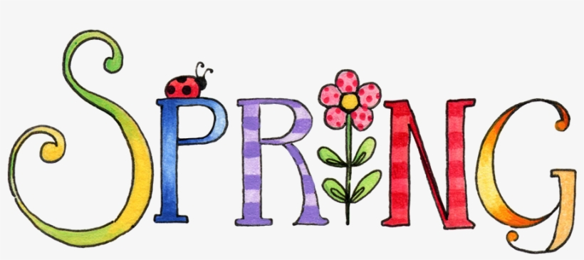

Computing

Digital Creativity

We will select, use and combine a variety of software on a range of digital devices to design and create a range of programs, design and create systems and content that accomplish given goals, including collecting, analysing, evaluating and presenting data and information.

PSHE

Relationships – Communication

We will be investigating ways in which we can communicate and how to build good communication skills.

Living in the Wider World – Collaboration. How can we work together? Building on collaborative skills.

DT

This half term our DT project will be looking at our digit world, the digit revolution and making our own digital charm. This will involve programming a micro-bit and designing an echarm.

PE

Indoor – Dance – Dances around the world.

Outdoor – Handball – Team work, skills, positions in the game and how to play as a team.

RE

Why are festivals important to religious communities?

We will be looking at similarities and differences between religious and non-religious celebrations and identifying reasons why people may choose to celebrate significant events.

Geography

Rivers

Why are rivers important to humans? We will be looking at the physical and human elements of rivers. The physical geography will include: climate zones, biomes and vegetation belts, rivers, mountains, volcanoes and earthquakes, and the water cycle

The human geography will include: types of settlement and land use, economic activity including trade links, and the distribution of natural resources including energy, food, minerals and water.

Music

We will be working on our Listening & Appreciation of music. Using;

Hebrides Overture (Mendelssohn)

Boomwhackers & notation

Sea shanties & Treasure Island songs

Science

Plants

We will be working scientifically, using our lines of enquiry to investigate plants. We will be identifying and describing parts of a flowering plant. We will understand the requirements of plants for life and growth. We will be describing the life cycle of a flowering plant –growth, flowering, pollination, seed formation and seed dispersal.