**Year 3**

English

Fiction – Story writing – using the text The Flood.

Non-fiction – Report writing – linked to the text The Street Beneath my feet.

We will be focusing on high quality vocabulary, neat handwriting and a variety of punctuation.

We will be encouraging the children to become more independent writers, to use editing skills to improve their work and write longer pieces of text.

We will be reading The Snow Walkers Son.as our class read. This text will also be used for discussions and comprehension during our reading lessons.

Reading – Reading targets have been set on Accelerated reader and Myon. Please encourage your child to use Myon, achieve their targets and be a weekly reading star.

Maths

Fractions - Building on our Fractions work during Spring term we will be deepening our understating of equivalent fractions and adding and subtracting fractions.

Measurements

Time – We will be telling the time using an analogue clock. Looking at minutes in an hour, days in a week, month and year including leap years.

Angles – How many degrees are there in a straight line, a right angle, an acute and obtuse angle?

Horizontal and vertical – Directional language.

Recognise and describe 3D shapes – How many side or vertices does a shape have? Can we describe shapes?

Mass and capacity – Reading a range of measures / scales for liquids (litres and millilitres) and solids (grams and kilograms).

**Summer 1**

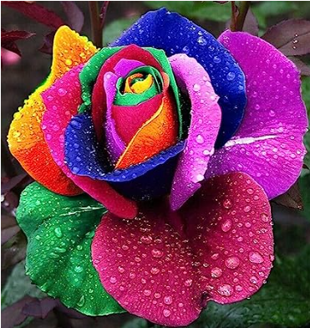

Science

Plants

We will continue our plant investigations this half term, building on our previous knowledge and carrying out further investigations in how plants grow and factors that might affect growth. We will Explore the requirement of plants for life and growth, and how they vary from plant to plant. What happens to plants when they are put in different conditions? We will be finding out all about seeds, seed dispersal and the life cycle of a plant.

Spanish

My Family – Mi Familia

We will be learning the Spanish names for members of our family and being able to name family members in Spanish.

PE

Outdoor Cricket – We will be learning the rules of the games, focusing on key skills (throwing, catching, batting and bowling) and working as a team.

Indoor Badminton – We will be working on hand to eye co-ordination and racket skills.

RE

What does it mean to be Christian in Britain today?

To explore how Christians show their beliefs at home, at church and in the local community.

History/Geography

Our focus this half term will be history. Our big question will be What are the similarities and differences between the earliest civilisations?

We will be looking at what we know about early civilisations already and how archaeologists and historians gather evidence. We will also be investigating when and where was the Shang Dynasty?

Art/DT

This half term we will be completing a Design and Technology project entitled Structures. We will be designing and constructing a castle using geometric shapes whilst following a given design criteria. We will be building on our previous investigation within our Art lessons - seeing shapes in particular objects.

PSHE

Core Theme 1 – Health and Well-being, Growing and changing and First aid

Children will be learning about how they change as they grow, how to look after their bodies and manage risks. How they can take responsibility for their own safety and the safety of others around them. They will also learn how our emergency services can help in a range of different situations and how to contact them.

Music

Rhythm

Being able to demonstrate the difference between beat and rhythm. Be able to Improvise stick rhythms and be able to maintain a part while others are playing a different rhythm. Be able to play both aurally and from notation. *Learn Repeat and Da Capo musical signs*