**Year 4**

Maths

This half term we will be learning all about Place Value. We will start by representing, partitioning and using number lines for numbers to 1,000, then we will represent numbers to 10, 000 e.g. on a number line and using place value counters. We will be finding 1, 10, 100, 1,000 more or less than any given number, comparing numbers to 10,000, ordering numbers to 10,000, Roman numerals and Rounding to the nearest 10, 100 and 1000.

A big focus for Y4 are our times tables so we will be practising those and expecting you to practise them at home too.

English

Reading

An introduction to Myon. An investigation into new vocabulary, looking at features of fiction and non-fiction texts and answering basic comprehension questions.

Class read – Krindlekrax.

This book will be read by the teaching team so the children can enjoy being read to. We will discuss features of the text and ambitious language.

Writing

We will be revisiting basic sentence structures including basic punctuation.

Fiction – The Real story of the three little pigs- A traditional tale.

Non- fiction- Skeletons and muscles – A non-chronological report.

**Autumn 1**

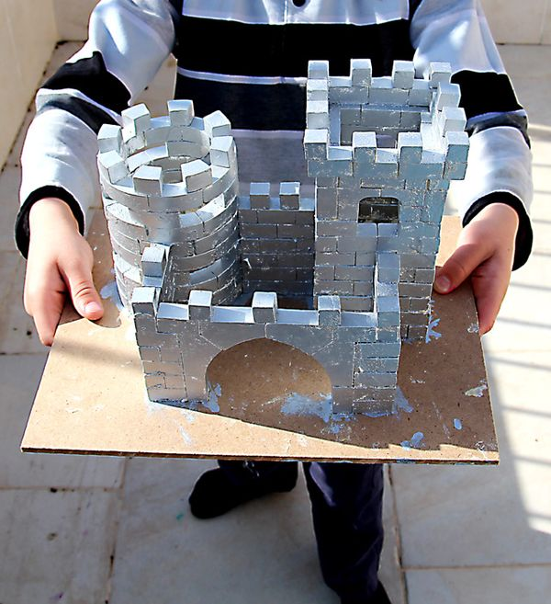

DT

In DT we will be constructing castles. We will us e our skills that we have developed in other year groups to make a string and rigid structure with a drawbridge

**Please save us old cereal boxes, kitchen rolls etc and send them for our models.**

RE

We will be asking ourselves ‘What do different people believe about God?’ We will be investigating Christian beliefs and Muslim beliefs. We will then compare similarities and differences.

PE

4B will be having swimming lessons on Wednesday mornings starting on the 10th of September.

Please remember to send your child with their costume and towel each week. Girls must ensure their hair is tied up.

PSHE

Classroom rules- how to be kind, respectful and show responsibility for ourselves, others and our belongings.

Healthy eating – we will be discussing how to have a balanced diet.

whilst online and not sharing personal information.

Science

Animals including humans (animal nutrition, skeletons and muscles).

To find out what different animals eat. Are they omnivores, carnivores or herbivores? What do these terms mean?

To identify animals skeletons and make comparisons. Can we identify an animal by looking at the skeleton? What similarities or differences appear in animal skeletons? Why?

To name some bones that make up the human skeleton & their function. Which bones help with movement and which protect certain important parts of our body?

To understand the purpose of muscles and how they work.

We will also be looking at investigations how to ask relevant questions and use different types of scientific enquiries to answer them

Music

We will be using body percussion to create pieces of music with a rain forest theme. We will layer sounds to create the effect of an orchestra.

Computing

We will be writing short programs using Scratch. We will learn that programs have events and actions. We will put this into practice by writing a maze tracing program.