**Year 4**

Maths

This half term we will be learning all about Place Value. We will start by representing, partitioning and using number lines for numbers to 1,000, then we will represent numbers to 10, 000 e.g. on a number line and using place value counters. We will be finding 1, 10, 100, 1,000 more or less than any given number, comparing numbers to 10,000, ordering numbers to 10,000, Roman numerals and Rounding to the nearest 10, 100 and 1000.

A big focus for Y4 are our times tables so we will be practising those and expecting you to practise them at home too.

English

Our first writing genre is based on Charlie and the Chocolate factory by Roald Dahl. We will build up vocabulary and sentence structures, including punctuation such as inverted commas and commas after fronted adverbials. This will lead to the children planning and writing their own independent story.

We will be answering a range of retrieval questions and learning new vocabulary based on Percy Jackson and the Lightning Thief, alongside developing our fluency in reading. We will also write a newspaper report based on this book.

**Autumn 1**

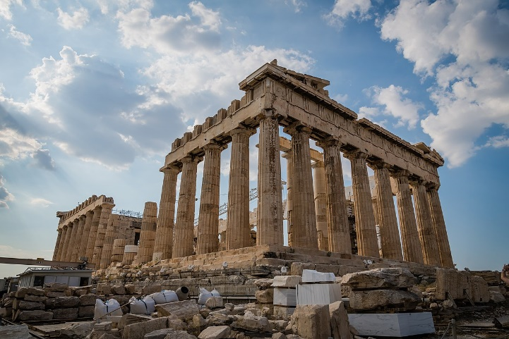

PSHE

We will be learning all about our identity and also how we use the internet safely. This will include questions such as: How do we keep ourselves safe online? How do we make sure that our online usage is acceptable? What is a stereotype? We will be learning how to manage our time online as well.

RE

Why is Jesus inspiring to some people?

This unit enables pupils to learn about Christianity in depth, through learning about the main events in Jesus’ life story, the difference between a parable and a miracle and why Jesus was considered a good teacher.

DT

In DT, we will be making Pavilions for our structure unit of work. We will use craft materials such as plasticine, toothpicks, A4 card, matchsticks, lolly sticks, straws, pipe cleaners and glue guns. The aim will be to make the structure as strong as possible.

Computing

Year 4 will be learning programming this half term. We will be building on the skills learned in Year 3 when using Scratch. We will explore the concept of repetition in programming using the Scratch environment. By the end of the unit, we will have the skills and knowledge needed to create our own game.

History

In history, we will be learning about the Ancient Greeks. We will start by comparing Ancient Greece with modern day Greece and thinking about why Ancient Greece is considered one of the world’s greatest civilisation. Our lessons will include learning about daily life, Alexander the Great and the Olympic Games.

Science

**How do humans and other animals get their nutrients?**

We will first look at the digestive system – learning about the different organs associated with digestion and their functions. The children will build on their knowledge of nutrition and animals from Key Stage 1. We will then look at teeth in humans and the functions of different types of teeth. We will also learn about how certain food and drink can damage our teeth.

We will also study food chains, learning how energy travels along a food chain and link animals’ teeth to their place in the food chain, eg herbivores, omnivores and carnivores.

PE

Children will do swimming and basketball on alternate weeks. In basketball we will practise skills such as dodging, passing and awareness of space.

Music

In music we will be focussing on composition & playing instruments with increasing control and expression. We will also be learning about pitch and timbre.