**Year 4**

Maths

This half term we will be leaning about multiplication and division. We will begin by learning about multiples of a times tables and focussing on times table patterns, progressing to using this knowledge to work out the multiplication and division of the 6, 9, 7 and 12 times tables. Alongside this, during mental maths sessions, we will be recalling the previous times tables we have learned.

English

This half term, we will be writing a play script and a letter to an author. Through the play script unit, we will be learning how dialogue is used to portray action, how stage directions are used, as well as focussing on how speech is presented differently. We will also be writing a formal letter to an author, focussing on how the choice of language can persuade someone to share your ideas.

Our class text is The Firework Maker’s Daughter by Philip Pullman and our reading lessons will be focussed on this.

**Autumn 2**

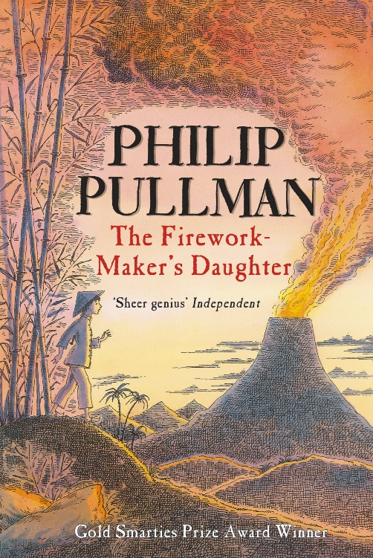

Music

Children will learn djembe drumming, holding and playing the drum correctly. We will also follow call and response rhythms, maintain a beat, improvise rhythms and play in several parts, including from notation.

Science

How can materials change state?

This half term in Science, we will be learning about how materials can change states to become solid, liquid or gas. We will begin by learning about the scientific definitions of a solid, a liquid or a gas and then use this knowledge to do a range of investigations, including classifying solids, liquids and gasses and observing what happens to a material when it is heated or cooled, making predictions about whether we think it will change state or not.

Geography

We will be learning about what it is like in the Northwest region of England. We will learn the counties in this region then will look more closely at some cities: Liverpool, Chester and Manchester. We will then look at features of geographical regions in the UK, before studying the Lake District in more detail,

Computing

Year 4 will be learning programming this half term. We will explore the concept of repetition in programming using the Scratch environment. By the end of the unit, we will have the skills and knowledge needed to create our own game.

Art

We will be covering 2 units of art this half term: 3D sculptures: Mega materials and Drawing: Power prints. In the first unit, we will be using a wide range of different materials to create 3D sculptures. During the drawing unit, we will be learning about proportion, symmetry and hatching to shade.

RE

We will be continuing to think about Jesus as an inspiration to Christians and answering the following questions:

Why was Jesus so important to Christians?

Why do Christians call the day Jesus died Good Friday?

Is Jesus still important today? Who to?

Who is inspiring for me?

PE

Both classes will be going swimming on alternate weeks.

When not swimming, we will be focusing on invasion games, including basketball. We will practise skills such as dodging, passing and awareness of space.

PSHE

This half term we be thinking about how we react to situations, our self-worth, persistence and resilience, negative persistence and what can happen if we overreact.