**Year 4**

Maths

This half term we will be learning about measurement including finding the perimeter of shapes and converting measures. We will also be learning about multiplication and division, with a focus on multiplying and dividing by 10 and 100 as well as the multiplication and division facts of the times tables.

English

This half term, we will be writing:

* A narrative based on the novel Bike Boy
* A newspaper article based on The Creature
* A Character Description

Our class text is The Firework Maker’s Daughter by Philip Pullman and our reading lessons will be focussed on this.

**Autumn 2**

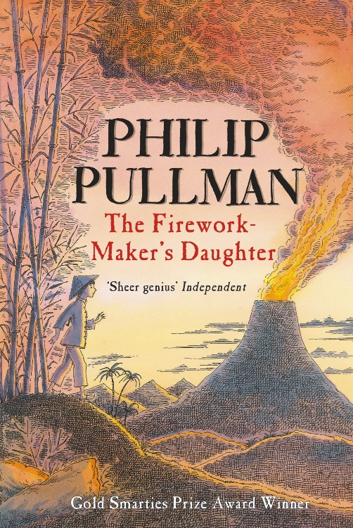

Geography

Our focus question is:

Is it possible to stop Earthquakes and Volcanoes?

We will be answering the following questions:

What is a volcano like?

Where do Earthquakes and Tsunamis happen?

What are the positive and negative impact of volcanoes? (tourism, farming, destruction)

How can we live with volcanoes, earthquakes and tsunamis?

DT

This half term we will be focussing on the question –

How can some buildings withstand natural disasters?

This will include thinking about how we can reinforce a structure. We will start by evaluating existing structures and then creating our own through measuring, marking out and combining materials.

PE

4H – We will be continuing swimming this half term.

4C – Our indoor PE session this half term will be Dance. For both classes our outdoor PE session will be Invasion Games. We will practise skills such as dodging, passing and awareness of space.

Computing

We are continuing our coding project and working together to achieve Paired Programming. We will be learning how to animate sprites using algorithms. We will become more familiar with using scratch.

RE

We will be continuing to think about Jesus as an inspiration to Christians and answering the following questions:

Why was Jesus so important to Christians?

Why do Christians call the day Jesus died Good Friday?

Is Jesus still important today? Who to?

Who is inspiring for me?

Science

Why are electrical circuits important?

Electricity – We will learn all about common appliances that run on electricity, construct a simple circuit and name the basic parts, recognise that a switch opens and closes a circuit and recognise some common conductors and insulators.

Music

We will be linking our Music to the Geography learning, making soundscapes to videos and learning about notation.

PSHE

This half term we be thinking about how we react to situations, our self-worth, persistence and resilience, negative persistence and what can happen if we overreact.