**Year 4**

English

Writing – Narrative – Using Phillip Pullman’s (an author we have met before this year) version of Aladdin as inspiration, children will be writing their own adventure story. The focus will be on character dialogue and the correct punctuation for this, as well as adverbial openers and apostrophes.

Reading – Our reading lessons this half term will be based on Little Flame and the Great Queen: The story of Boudicca. Written at the time of the Roman invasion, children will use this story for the vocabulary, verbal and written comprehension.

Maths

In Maths this term, we are continuing to learn all about fractions. This will then lead into decimal work where we will be recognising tenths and hundredths, writing them as decimals, writing them onto a place value grid and also on a number line. We will also be dividing one and two digit numbers by 10 and 100 to understand how that creates a decimal number.

**Spring 2**

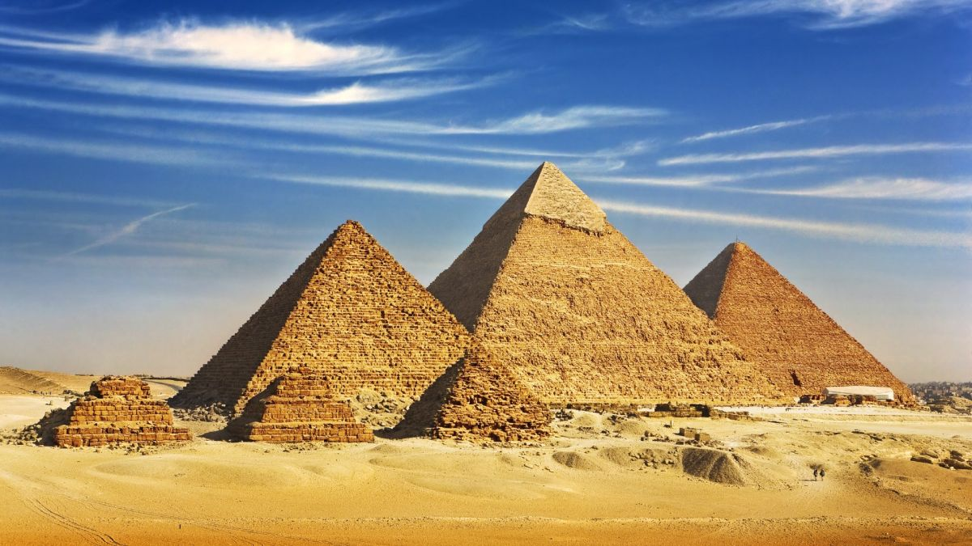

PE

4C – This half term, 4C will continue with their gymnastics unit of work. They will be practising their movement, travelling, balancing and group work, creating sequences of moves.

4H will be continuing with their swimming lessons

RE

**What does it mean to be a Hindu in Britain today?**

This half term, we will build on our knowledge from Year 3 by looking at the Hindu faith in more detail. We will focus on how Hindus show their faith and what is important to a Hindu in their every day life. We will also learn why Mahatma Gandhi was a Hindu hero and look at what it is like to be a Hindu in Britain today.

Art

We will use Painting and mixed media this half term to express light and dark in pictures. We will learn the difference between tint and shade and then use this to create a three dimensional picture.

Music

This half term, we will be developing our skills in reading notation and learning how to sight sing from music.

History

**Why is Ancient Egypt considered to be an Early Civilisation?**

In History, we will be learning about Ancient Egypt as a civilisation. We will learn about when the Ancient Egyptian period occurred and where in the world. We will also learn why the River Nile was so important to their progress. We will also learn why Tutankhamun and the pyramids were significant as well as daily life in Ancient Egypt.

Spanish

In our Spanish lessons, we will developing our learning from unit one (numbers) to learn to say the date in Spanish. This will involve learning the days of the week and months of the year in Spanish. They will then use this knowledge to tell others their birthday.

PSHE

This half term we will be focussing on family. We will be looking at who is in our family and the roles played by different family members. We will also be developing strategies to manage strong emotions.

Science

**Why are electrical circuits important?**

This half term, our focus is on electricity and circuits. We will learn all about common appliances that run on electricity and those that run on batteries and the differences between them. We will also construct a simple circuit, name the basic parts and draw them. We will also learn about the importance of switches and how they open and close a circuit and finally, recognise some common conductors and insulators in circuits.