**Year 4**

English

Writing – Narrative – Using Phillip Pullman’s (an author we have met before this year) version of Aladdin as inspiration, children will be writing their own adventure story. The focus will be on character dialogue and the correct punctuation for this, as well as adverbial openers and apostrophes.

Reading – Our reading lessons this half term will be based on Little Flame and the Great Queen: The story of Boudicca. Written at the time of the Roman invasion, children will use this story for the vocabulary, verbal and written comprehension.

Maths

In Maths this term, we are continuing to learn all about fractions. This will then lead into decimal work where we will be recognising tenths and hundredths, writing them as decimals, writing them onto a place value grid and also on a number line. We will also be dividing one and two digit numbers by 10 and 100 to understand how that creates a decimal number.

**Spring 2**

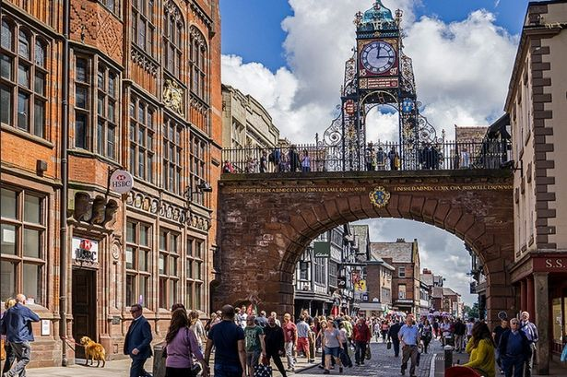

PSHE

This half term we will be focussing on relationships. We will be discussing where to go to for help and advice, and how to show consideration for other people’s views. We will also talk about coping with loss and separation, and family changes.

History

**What was the impact of the Roman Empire on Britain?**

In history, we will look at the expansion of the Roman Empire, the significant changes the Romans made, and the legacies left by the Romans. We will also look at the significance of the Roman Army in the expansion of the Empire, and the rebellion led by Boudicca.

PE

Both classes will be continue with swimming lessons on alternate weeks. Outdoor games will be hockey, developing the skills to move the ball accurately and work as a team; in indoor PE we will be doing a dance based on our history unit of the Romans.

RE

**Why are festivals important to religious communities?**

This half term, we will be looking at what we celebrate, and the different types of celebration that we might take part in. We will then look more closely at the celebration of Easter, and the events leading up to Easter Sunday morning. We will then learn about the Hindu festival of Diwali, and the significance of the goddess Lakshmi.

Art

We will use Painting and mixed media this half term to express light and dark in pictures. We will learn the difference between tint and shade and then use this to create a three dimensional picture.

Music

This half term, we will be developing our skills in reading notation and learning how to sight sing from music.

Computing

In our Computing lessons, we will be looking at how the internet, networks and the World Wide Web. We will learn how networks are connected and how the internet works. We will talk about websites, who owns content, and the reliability of information we find online.

Science

**Why are electrical circuits important?**

This half term, our focus is on electricity and circuits. We will learn all about common appliances that run on electricity and those that run on batteries and the differences between them. We will also construct a simple circuit, name the basic parts and draw them. We will also learn about the importance of switches and how they open and close a circuit and finally, recognise some common conductors and insulators in circuits.