**Year 4**

English

Non – Fiction – We will write a holiday brochure, with a focus on using persuasive language.

Narrative – Mystery story based on the Chocoplot. We will be looking at sentence structure, dialogue and use of possessive apostrophes.

Reading – The Great Chocoplot by Chris Callaghan. The focus this half term will be on giving reasons for events in stories, based on evidence in the text. We will also look at language choices and how this engages the reader.

Maths

Decimals – Writing, comparing, ordering and rounding decimals, linking these to the fractions 1/10 and 1/100.

Money – Pounds and Pence, estimating, converting, adding and subtracting money

Time – Telling the time to 1 minute and 5 minutes, AM and PM, 24 hour clock

Times Tables – Practising in preparation for the Times Tables test

**Summer 1**

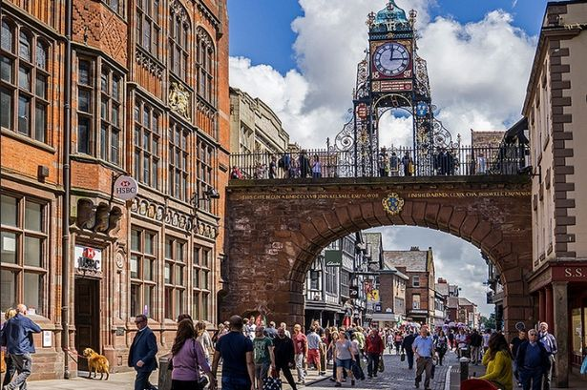

PE

Rounders – We will learn the skills associated with bowling, batting and fielding - practising throwing and catching skills, battling skills, and how to perform effectively in different fielding positions. We will then put these skills into practice, working as a team to play a game of rounders.

Swimming will continue for 4H

DT

**Electrical systems: torches**

We will identify the features of a torch and what makes a torch successful.

We will then create a functioning torch with a switch based on our design criteria.

Science

**Electricity**

We will continue learning about circuits, making and testing predictions as to whether they will work.

**How are living things grouped?**

We will look at differences between living things (animals and plants), and then look further into how living things are grouped, using keys to classify and sort them. We will also look at how humans can have an impact on environments.

PSHE

**Strengths and setting goals**

During this unit, children will be thinking about what they are good at, and planning for the future. We will also help children learn how to recognise and manage feelings in a positive way,

RE

**What does it mean to be a Hindu in Britain today?**

How do Hindu’s show their faith?

A Hindu life, what is important?

Why was Mahatma Gandhi a Hindu hero?

What is it like to be a Hindu in Britain today?

Computing

Our unit is audio-editing. We will be able to identify digital devices that play and record audio. We will also record and playback sound. We will then plan the content of a podcast, record and edit it, and evaluate our final product.

History

**What was the impact of the Roman Empire on Britain?**

Focussing on significance and change, we will be learning about when the Roman Empire was, how the empire became so powerful, how Britain became part of the empire and who Boudicca was. We will also learn about the changes Romans made to Britain.

Music

 Y4 Learn how music and its purposes have changed over time (Romans).  Develop singing skills, both aurally, from notation and in several parts. Be able to explain the difference between beat and rhythm and clap/sing both together in 2/4, 3/4 and 4/4 time signatures.