**Year 4**

Maths

This half term we will be learning all about Multiplication including multiplying by 10 and 100, dividing a number by 10 and 100, multiplying a 2 or 3 digit number by a 1 digit number and dividing a 2 or 3 digit number by a 1 digit number. We will also be working out the length and perimeter of shapes,

English

Poetry – Still I rise – We will be looking at the poem originally written by Maya Angelou and using it as inspiration for our own poem.

Factual tour - We will write a script for a factual tour of the school.

Reading Lessons – We will be reading Journey to Jo’Burg by Beverley Naidoo. We will be learning some new vocabulary in context and using the text to answer questions using evidence and giving reasons for our choices.

**Spring 1**

Music

To play instruments musically by playing, improvising and harmonising to a set key and following notated rhythms. Learn about the tonic (home note) and different tonalities in musical excerpts and be able to recognise major and minor keys.

Spanish

We will be continuing our Spanish lessons by: learning then names of fruit and vegetables, counting, and asking politely. This includes asking and answering questions about our favourite fruit and vegetables and describing their colours.

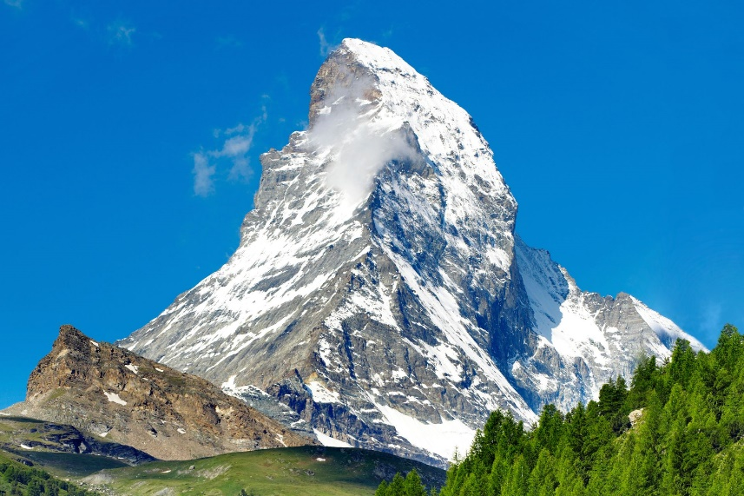

PSHE

In PSHE, we will learning about keeping healthy through having a balanced diet. We will also be learning about where food comes from and how different food groups contribute to a balanced diet.

Geography

We will be learning about Mountains including what mountains are and how they are formed, we will be learning about which mountains in the world are known as the seven summits – the highest peak on each continent, we will discuss the weather and climate on a mountain and will conclude with a virtual trek to Everest Base Camp.

PE

Both classes will be going swimming on alternate weeks.

When not swimming, we will be playing tag rugby and learning to work as a team. We will also have dance sessions where we create movements to music.

DT

In DT, we will be learning about mechanical systems and using this knowledge to produce a slingshot car. Children will create the chassis and launching mechanism, design the car body, assemble, and evaluate their design.

RE

We will be learning about what a life journey is and what that means to us. We will be looking at significant ceremonies in different religions such as: Bar/Bat Mitzvah in Judaism, the sacred thread ceremony in Hinduism and what weddings look like in different religions.

Science

We will be continuing our learning of Solids, Liquids and Gasses. Building on our prior knowledge, we will be researching the melting points of a variety of materials e.g. rocks and metals, we will also be investigating how the rate of evaporation is affected by temperature and linking this knowledge to the water cycle: identifying the part played by evaporation and condensation.