**Year 4**

English

Narrative – The Journey – Sentence structure, using basic punctuation and descriptive language.

Book Study – We will be reading Charlotte’s Web this half term, studying the characters and the plot.

Reading Lessons – These will focus on reading

texts for fluency and answering literal questions.

Maths

This half term we will be learning all about Place Value including: Roman Numerals, Rounding to the nearest 10 and 100, Counting in 1000s, Partitioning, Using number lines to 10, 000, 1000 more or less, Comparing and Ordering numbers, Rounding to the nearest 1000, negative numbers, adding, subtraction and estimation.

**Autumn 1**

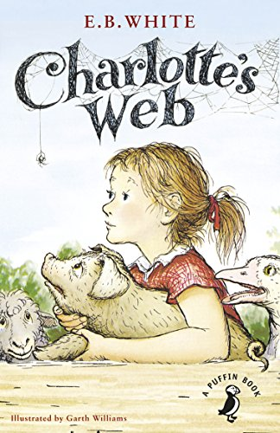

PE

Indoor PE – Badminton (Friday) We will be learning how to serve, hit the shuttlecock over the net and work with a partner to rally.

Outdoor PE – Basketball – 4C

Swimming – 4H

PSHE

How do we keep ourselves safe online?

How do we make sure that our online usage is acceptable? What is a stereotype?

RE

Why is Jesus inspiring to some people?

This unit enables pupils to learn in depth from Christianity, exploring different reasons why Jesus is considered an inspiring figure by Christians – and by many other people too.

Computing

Year 4 will be taking part in an exciting project for the first school term. They will be working together, learning how to code on the laptop with a focus on teamwork.

DT

Mechanisms – Making a flagpole with a working pulley mechanism. We will design our system, make it, try it and then evaluate it.

Music

In music we will be focussing on composition & playing instruments with increasing control and expression.

Science

We will be learning all about living things and their habitats (animal/plant groups, use keys, environmental changes) and trying to have a positive impact on a habitat. We will also try and answer the following:

How are living things grouped? How can we identify animals and plants? What happens if a habitat changes?