**Year 5**

Maths

Place Value

Numbers to 10,000; 100,000 and 1,000,000

Rounding numbers to 1,000,000

Comparing and ordering numbers to 1,000,000

Negative numbers

Addition and Subtraction

Adding whole numbers with more than 4 digits

Subtracting whole numbers with more than 4 digits

Rounding to approximate and estimate

Inverse operations

Multi-step addition and subtraction problems

English

Writing

We will be writing a story based on the book ‘Gorilla’ by Anthony Browne, focussing on using correct punctuation for sentences, including punctuating adverbial phrases correctly. We will also be writing diaries based on characters from our class book.

Reading

We will be reading the book ‘Explorer’ by Katherine Rundell. We will be reading this for pleasure and to develop skills of comprehension.

**Autumn 1**



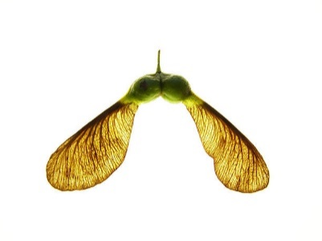

PSHE

We will be thinking about our class and school rules before moving onto learning how to keep ourselves safe with adults, considering what makes a positive role model, thinking about the words we use and developing skills of self-respect and self-worth.

RE

Why do some people think God exists?

The children will discuss this topic through the key questions below

Why do some people believe in God?

What does it mean to be an atheist?

Who or what is God to Christians?

What is the difference between fact, opinion and belief?

What do Christians believe about the creation of the Earth?

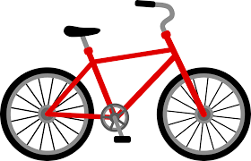

Science

We will start the term by looking at the school garden and investigating plants at different stages of their life cycles. This theme will continue across the year. We will then move onto our unit on forces with our big question of, ‘What do forces do?’

We will be looking at forces: friction, air and water resistance, and how simple machines such as pulleys, gears and levers work. The children will undertake investigations to test the effects of air and water resistance and develop their understanding of comparative and fair tests.

Art

The children will Investigate the built environment through drawing and print making, learning about the work of architect Zaha Hadid and creating their own building designs, creatively presenting research on artist Hundertwasser and exploring ideas behind the symbolism of monument design.

Computing

The children will be developing their coding skills using Scratch. They will be developing their knowledge of ‘selection’ by revisiting how ‘conditions’ can be used in programming, and then learning how the ‘if… then… else...’ structure functions to create a quiz.

Geography

Our topic is all about ‘What is England’s place in the world?’ By the end of the unit children will be able to describe England’s location in the world - developing a more detailed knowledge through learning about lines of longitude and latitude, time zones and climate zones. We will also discuss global warming and its consequences.

Music

Through the theme of Egypt, the children will develop their singing skills before moving onto reading simple notation and writing their own piece of music.

PE

This half term the children will be developing their cross-country running skills and improving their team games skills through handball, basketball, unihoc.and netball.