**Year 5**

English

Writing

We will be writing a story based on the book ‘Gorilla’ by Anthony Browne, focussing on using correct punctuation for sentences, including punctuating adverbial phrases correctly. We will also be writing diaries based on characters from our class book.

Reading

We will be reading the book ‘Explorer’ by Katherine Rundell. We will be reading this for pleasure and to develop skills of comprehension.

Maths

Place Value

Numbers to 10,000; 100,000 and 1,000,000

Rounding numbers to 1,000,000

Comparing and ordering numbers to 1,000,000

Roman Numerals

Negative numbers

Addition and Subtraction

Adding whole numbers with more than 4 digits

Subtracting whole numbers with more than 4 digits

Rounding to approximate and estimate

Inverse operations

Multi-step addition and subtraction problems

**Autumn 1**



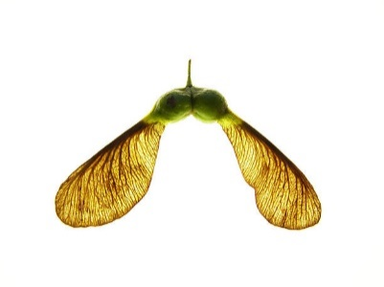

PSHE

We will be thinking about our class and school rules before moving onto work developing emotional literacy, through the use of zones of regulation.

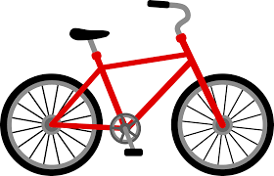

RE

Why do some people think God exists?

Why do some people believe in God?

What does it mean to be an atheist?

Who or what is God to Christians?

What is the difference between fact, opinion and belief?

What do Christians believe about the creation of the Earth?

Geography

Our topic is all about ‘What is England’s place in the world?’ By the end of the unit children will be able to name and talk about a range of countries around the world and their capital cities. They will learn about lines of longitude and latitude and time zones.

Art

Using inspiration of historical monuments and modern installations, children will plan by researching and drawing, a sculpture to fit a design brief.

They will they go on to Investigate the built environment through drawing and print making, learning about the work of architect Zaha Hadid and creating their own building designs, creatively presenting research on artist Hundertwasser and exploring ideas behind the symbolism of monument design.

Science

Our big question is ‘What do forces do?’

We will be looking at forces: friction, air and water resistance, and how simple machines such as pulleys, gears and levers work. The children will undertake investigations to test the effects of air and water resistance and develop their understanding of comparative and fair tests.

We will also be introducing our year theme of life cycles and begin by observing local plants.

PE

Indoor- Badminton – We will be learning how to execute a variety of shots and develop our hand eye coordination.

Outdoor- Football- We will be learning the skills of passing, dribbling, shooting and defending and incorporating all of these into a game.

Computing

The children will be developing their coding skills using Scratch. They will be developing their knowledge of ‘selection’ by revisiting how ‘conditions’ can be used in programming, and then learning how the ‘if… then… else...’ structure functions to create a quiz. They will also be looking at E-safety and how to show respect when online.

Music

The children will be learning how to compose and play ostinato rhythms.