**Year 5**

Maths

This half term we will be working on multiplication and division through prime, square and cube numbers and multiplying and dividing by 10, 100, 1000.

We will also be working on fractions. We will be finding equivalent fractions, comparing and ordering and Adding and subtracting fractions.

We will also focus on learning key number facts – prime and square numbers, and recap and revise addition and subtraction strategies.

English

This half term we will be looking at two different genres of text. Non chronological reports and a story. The children will complete writing units of work on these before writing their own versions.

In reading we will be reading non-fiction texts based on the penguins and then writing our own based on the Emperor Penguin. We will also be reading Street Child by Berlie Doherty.

**Autumn 2**

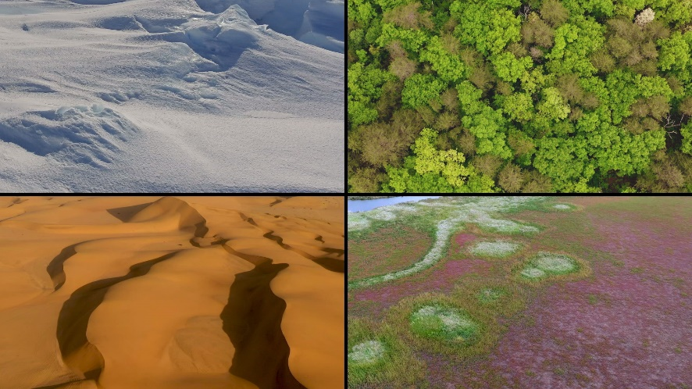

History

This half term, we will be learning about the Anglo-Saxons and how they changed Britain. We will learn who they were and where they came from, why they chose to settle in Britain, their significant leader, how we have learned so much about them and why religion was important to them. This builds on the previous learning about the Romans in Britain.

Spanish

We will be recalling numbers 1-20 and learning how to say the days and months. We will be asking and answering questions about ourselves and learning vocabulary for school rooms and classroom items.

Science

This half term we will be completing our work on Forces, looking at how gears, levers and pulleys work.

We will then go onto learning about the properties of materials, learning about thermal conductors and insulators and comparing how materials can have different properties such as being or magnetic or electrical insulators. We will consider how different materials are suited to different purposes.

RE

This half term we will be answering the big question -

What would Jesus do? Can we live by the values of Jesus in the twenty-first century? – through studying the following questions:

* What did Jesus say?
* What was the mission of Jesus?
* How can Christians demonstrate they follow Jesus?
* Why is forgiveness important to Christians?
* How can you know if someone is aChristian?
* What did Jesus teach aboutgenerosity?

Music

In music, we will develop skills in reading standard notation, play pieces on pitched instruments from notation and begin to understand how they are structured. We will learn to compose by re-arranging musical ideas and by improvising and begin to learn about tonality and harmonising.

Art/DT

We will be completing our work on Architecture by looking at creating monuments.

We then move onto creating Doodler toys using circuits and electrical components.

PSHE

In PSHE this term, we will be continuing our work with the Zones of Regulation and also looking at Remembrance and what this means. We will also be looking at managing conflict.

PE

This half term we will be developing our dance skills by looking at dance through the ages and learning a variety of different styles of dance. We will also develop our ball skills of throwing, catching and shooting through the game of netball.