**Year 5**

Maths

Place Value

Numbers to 10,000; 100,000 and 1,000,000

Rounding numbers to 1,000,000

Comparing and ordering numbers to 1,000,000

Roman Numerals

Negative numbers

Addition and Subtraction

Adding whole numbers with more than 4 digits

Subtracting whole numbers with more than 4 digits

Rounding to approximate and estimate

Inverse operations

Multi-step addition and subtraction problems

Statistics

Drawing, reading and interpreting line graphs

Reading and interpreting tables

Two way tables and timetables

English

Writing

Zoo- narrative- using relative clauses, similes, adverbials, exciting vocabulary.

Emperor penguins- Non- chronological report. - Organisation of a report, research.

Reading

Vocabulary building – Using dictionaries and thesauruses, class reading.

Comprehension skills- develop knowledge of a wide range of texts and be able to summarise key points.

**Autumn 1**

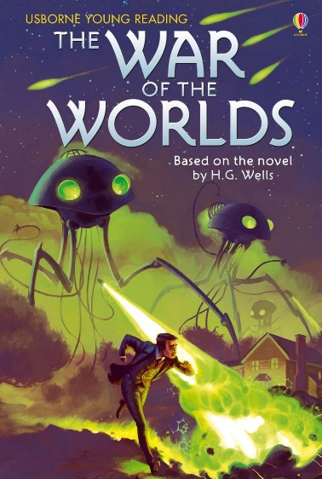

PE

Indoor- Fitness- circuit training to improve fitness. This will include a range of different exercises focussing on different body parts with a timed element to produce our PB.

Outdoor- Football- We will be learning the skills of passing, dribbling shooting and defending and incorporating all of these into a game

Art/DT

We will be working on 3D sculpture using clay. We will study the artist Rowena Brown, looking closely at the techniques she used and the pieces she produced.

We will then use a range of her techniques to join two pieces of clay using a range of equipment.

PSHE

Rules and responsibilities- Government, law and order, differences between home and school, why we need rules.

Online relationships- how to stay safe online.

RE

Why do some people think God exists?

Why do some people believe in God?

What does it mean to be an atheist?

Who or what is God to Christians?

What is the difference between fact, opinion and belief?

What do Christians believe about the creation of the Earth?

Spanish

How to say hello and goodbye at different times of the day.

Asking someone’s name.

Formal and informal greetings for different occasions.

Asking how are you and giving an answer

Colours

Book Study

We will be reading the children’s version of the Sci-Fi classic, War of the Worlds. We will engage in exploring this classic science fiction novel through a range of drama, art and creative writing activities.

Music

Ostinato & Holst's Planet Suite – we will be listening to the music Holst created for each planet and using our music skills to relate the pieces to our science knowledge of the planets

Science

We are studying Earth and Space this half term. We will be answering the following questions using a range of research and practical activities:

* What do I know about the earth, sun and moon?
* Do the earth, moon and sun move?
* What planets are in our solar system? How do they move?
* How do we get day and night?
* How does a meteorite affect the size of its crater?

And our big question:

* What is the solar system?