**Year 5**

Maths

Place Value

Numbers to 10,000; 100,000 and 1,000,000

Rounding numbers to 1,000,000

Comparing and ordering numbers to 1,000,000

Roman Numerals

Negative numbers

Addition and Subtraction

Adding whole numbers with more than 4 digits

Subtracting whole numbers with more than 4 digits

Rounding to approximate and estimate

Inverse operations

Multi-step addition and subtraction problems

English

Writing

We will be writing a unit of story based on the book Gorilla by Anthony Browne. We will be focussing on using correct punctuation for sentences, including punctuating adverbial phrases correctly. We will also focus on using correct spellings for key words.

Reading

We will be reading the book Tom’s Midnight Garden by Philippa Pearce. We will be reading this for pleasure and to develop skills of comprehension.

**Autumn 1**



PSHE

Rules and responsibilities- Government, law and order, differences between home and school, why we need rules.

Online relationships- how to stay safe online.

Science

Our big question is ‘What do forces do?’

We will be looking at forces – and water resistance, gravity and how pulleys and levers work. The children will design investigations to test the effects of air and water resistance and develop their understanding of comparative and fair tests.

We will also be introducing our year theme of life cycles and being by observing local plants and stick insect eggs which we hope will grow into adults and reproduce later in the year.

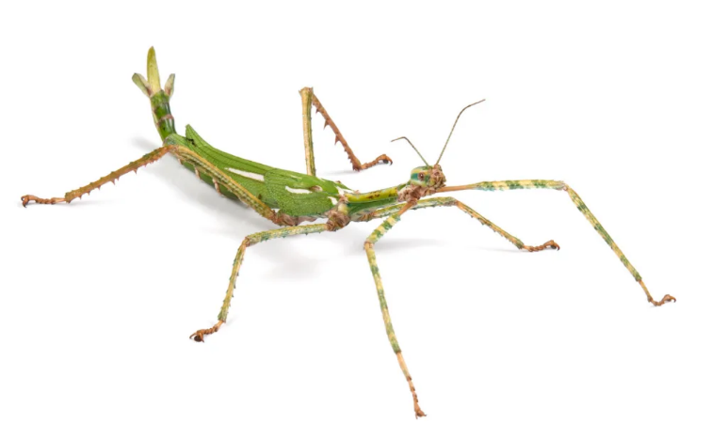

RE

Why do some people think God exists?

Why do some people believe in God?

What does it mean to be an atheist?

Who or what is God to Christians?

What is the difference between fact, opinion and belief?

What do Christians believe about the creation of the Earth?

Art

Using inspiration of historical monuments and modern installations, children will plan by researching and drawing, a sculpture to fit a design brief. They will investigate scale, the display environment and possibilities for viewer interaction with their piece. They will they go on to Investigate the built environment through drawing and print making, learning about the work of architect Zaha Hadid and creating their own building designs, creatively presenting research on artist Hundertwasser and exploring ideas behind the symbolism of monument design.

Geography

Our topic is all about ‘What is England’s place in the world?’ By the end of the unit children will be able to name and talk about a range of countries around the world and their capital cities. They will learn about time zones.

PE

Indoor- Badminton – We will be learning how to execute a variety of shots and develop our hand eye coordination.

Outdoor- Football- We will be learning the skills of passing, dribbling, shooting and defending and incorporating all of these into a game

Computing

The children will be developing their coding skills using Scratch. They will be developing their knowledge of ‘selection’ by revisiting how ‘conditions’ can be used in programming, and then learning how the ‘if… then… else...’ structure functions. They will use this to create a quiz.

Music

The children will be learning how to compose and play ostinato rhythms.