**Year 5**

Maths

This half term we will be working on multiplication and division through prime, square and cube numbers and multiplying and dividing by 10, 100, 1000.

We will also be working on fractions. We will be finding equivalent fractions, comparing and ordering and Adding and subtracting fractions.

We will also focus on learning key number facts – prime and square numbers, and recap and revise addition and subtraction strategies.

English

This half term we will be looking at two different genres of text. Non chronological reports and a story. The children will complete writing units of work on these before writing their own versions.

In reading we will be reading non-fiction texts based on the Emperor Penguin and animals from the Rainforest before moving on to reading and studying the classic, A Christmas Carol by Charles Dickens.

**Autumn 2**

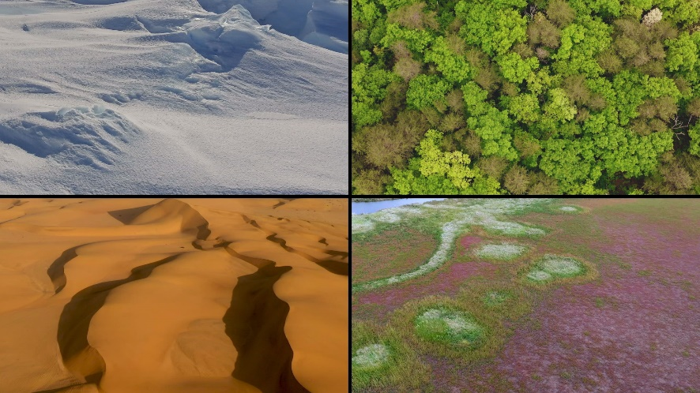

Spanish

This half term we will be learning about numbers to 100. The children will then use these to play number games and learn how to pay for items in Spanish.

Science

This half term we will be completing our work on Forces, looking at how gears, levers and pulleys work.

We will then go onto learning about the properties of materials, learning about thermal conductors and insulators and comparing how materials can have different properties such as being or magnetic or electrical insulators. We will consider how different materials are suited to different purposes.

RE

This half term we will be answering the big question -

What would Jesus do? Can we live by the values of Jesus in the twenty-first century? – through studying the following questions:

* What did Jesus say?
* What was the mission of Jesus?
* How can Christians demonstrate they follow Jesus?
* Why is forgiveness important to Christians?
* How can you know if someone is aChristian?
* What did Jesus teach aboutgenerosity?

Geography

This half term, following on from our work on climate zones in the first half term, we will be learning about six different biomes around the world. We will focus in more detail on the rainforest, hot desserts and savannah. We will discuss the importance of these biomes and some of the animals and plants that can be found in them.

Music

In music, we will develop skills in reading standard notation, play pieces on pitched instruments from notation and begin to understand how they are structured. We will learn to compose by re-arranging musical ideas and by improvising and begin to learn about tonality and harmonising.

Art/DT

We will be completing our work on Architecture looking at the work of Friedensreich Hundertwasser.

We then move onto creating Doodler toys using circuits and electrical components.

PSHE

In PSHE this term, we will be looking at Remembrance and what this means, managing conflict in our relationships and supporting the community. We will complete tasks that will help us to gather skills to deal real life situations.

PE

This half term we will be developing our dance skills by looking at dance through the ages and learning a variety of different styles of dance. We will also develop our ball skills of throwing, catching and shooting through the game of netball.