**Year 5**

English

This term in Writing, we will be writing a story and a diary. The story is about a present and is a story with an underlying meaning. The dairy is about Scott of the Antarctic and his mission to reach the South Pole. In reading we will be continuing to develop comprehension and fluency skills through the reading of our class novel Street Child by Berlie Doherty.

Maths

In maths this term we will be learning to multiply and divide using short and long multiplication methods and short division methods. We will also be continuing to learn about fractions, including equivalent fractions, fractions of amounts, adding and subtracting fractions, converting between mixed numbers and improper fractions and multiplying fractions by integers.

This means we need to be very secure in our recall of times tables facts so this needs lots of practice at home.

**Spring 1**

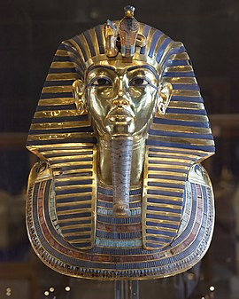

Art

Our unit this half term is entitled I need Space. The children will Use past knowledge and experience to explore a range of drawing processes. They will select and place textures to create a collagraph plate and print.

RE

This term we will answering the big question, ‘If God is everywhere, why go to a place of worship?’ through studying how Christian, Jewish, Hindu and Muslim beliefs shape their different places of worship. We will have a Jewish visitor and will visit a church.

PSHE

In PSHE this term, we will be talking about healthy lifestyles. We will be thinking about the three aspects of a healthy lifestyle: physical, emotional and mental health. We will be looking at how we can have a healthy lifestyle and who can help us.

PE

This term the children are working on gymnastics and on being leaders of PE - planning and leading games they have designed themselves with younger children.

Computing

This term the children are working on digital creativity, creating and editing their own videos with a message. They will learn how to take different types of shots and add audio and effects.

Science

This half the term, the children will be continuing with their work on properties and changes of materials. They will be considering making solutions and mixtures and how these can be separated by sieving, use of magnetism, filtering and evaporation. They will be looking at the work of chemists and how materials change when heated, whether changes are reversible or irreversible forming a new material.

Music

In music, we will be learning to sing with increasing accuracy and expression. We will sing in several parts and improve our reading of standard notation.

History

The children will be learning about Ancient Egypt, the achievements of this early civilisation and when in time it occurred.

They will learn about the importance of the River Nile and its use in agriculture, how the society was organised and what they believed in.