**Year 5**

Maths

We will be completing our work on fractions – finding fractions of amounts, before moving onto learning about decimals and percentages.

We will be looking at equivalence between fractions, decimals and percentages and using these conversions to solve problems.

Then we will move onto finding perimeters and areas of rectangles and compound shapes.

English

This half term we will be looking at one type of genre; a story. Our story will be based on the book ‘The Nowhere Emporium’. We will be writing about how Daniel is introduced to the emporium.

Our reading lessons will also be based on the same book and there will be a focus on deepening their understanding of a text

**Spring 2**

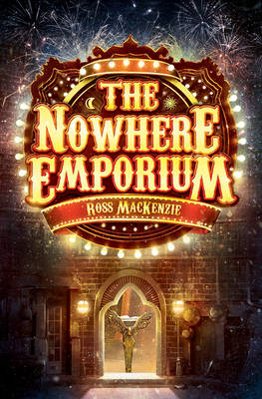

History

In History, we will be learning all about the Ancient Greeks. Throughout the topic we will be learning about how the Ancient Greeks achievements have impacted western world. We will learn about, who the Ancient Greeks were and significant figures, such as Alexander the Great. We will also be learning about life in Ancient Greece, including religion and the Olympics.

DT

In DT this half term, we will be looking at creating our own pop-up storybook on a simple story or rhyme.

Children will design and create the structure of their own book, which will include various mechanisms and decorative features such as: structures, levers, sliders, layers and spacers.

Throughout this unit they will learn how to make mechanisms and structures by using sliders, pivots and folds to produce movement.

RE

This half term we will be continuing to answer the big question, ‘If God is everywhere, why go to a place of worship?’ through answering the following questions:

* How do features in a church help believers?
* How do Christians shape their place of worship?
* Why is pilgrimage important to Hindus?
* How does the synagogue help Jewish worship?

PSHE

In PSHE this term, we will be focusing on being healthy, through diet and lifestyle. As a part of this topic, we will look at creating a healthy meal and the food groups that will make up a healthy plate of food.

Music

In music, we will be continuing from spring 1 learning to sing with increasing accuracy and expression. We will also be learning Rainforest Songs/sounds composition, using the samba instruments to do this.

Spanish

In Spanish, we will be learning the Spanish vocabulary for days, months, dates. We will then use this to create sentences about birthdays and other important dates in the year. This will help the children to create longer passages of writing in Spanish.

PE

Our indoor PE, will be focusing on multi-skills and fitness where we will focus on teamwork, building on last half term’s skills.

In outdoor PE, we will be learning how to play Cricket focussing on how to work as a team, throwing, catching, batting and fielding.

Science

In science, we will be completing our work on properties of materials and in particular looking at reversible and irreversible changes.

After this we will be moving onto Living Things and their Habitats which includes comparing the life cycles of different types of animals: mammals, birds, amphibians and insects as well as how animals grow, change and reproduce. We will be learning about sexual and asexual reproduction in plants.