**Year 5**

Maths

We will be completing our work on fractions – finding fractions of amounts, before moving onto learning about decimals and percentages.

We will be looking at equivalence between fractions, decimals and percentages and using these conversions to solve problems.

Then we will move onto finding perimeters and areas of rectangles and compound shapes.

English

This half term we will be looking at one type of genre; a story. Our story will be based on the book ‘The Nowhere Emporium’. We will be writing a fantasy story using this book as a stimulus.

Our reading lessons will also be based on the same book and there will be a focus on deepening their understanding of a text.

**Spring 2**

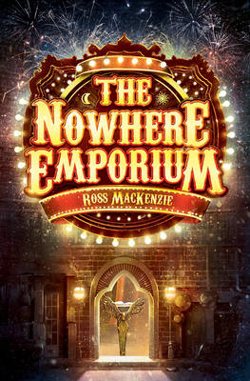

History

In History, we will be answering the question, ‘What impact did the Viking invasion have on Anglo-Saxon Britain?’ Building on the previous unit, children will learn about how Britain became first a target for the Vikings to raid, then a place for them to settle. As well as this, they will learn about the struggle for control of power in Britain and the changes that the Vikings made to Britain.

DT

In DT this half term, we will be looking at creating our own pop-up storybook on a simple story or rhyme.

Children will design and create the structure of their own book, which will include various mechanisms and decorative features such as: structures, levers, sliders, layers and spacers.

Throughout this unit they will learn how to make mechanisms and structures by using sliders, pivots and folds to produce movement.

RE

This half term we will be continuing to answer the big question, ‘If God is everywhere, why go to a place of worship?’ through answering the following questions:

* How do features in a church help believers?
* How do Christians shape their place of worship?
* Why is pilgrimage important to Hindus?
* How does the synagogue help Jewish worship?

PSHE

In PSHE this term, we will be focusing on the importance of being a good listener to build good relationships. We will also be thinking about who we can rely upon if we have any problems.

Music

In music, we will be continuing from spring 1 learning to sing with increasing accuracy and expression. We will also be learning Rainforest Songs/sounds composition, using the samba instruments to do this.

Spanish

In Spanish, we will be learning the Spanish vocabulary for classroom commands before moving onto the names for shops and asking for directions. We will also revise names for colours.

PE

Our indoor PE, will be focusing on multi-skills and fitness where we will focus on teamwork, building on last half term’s skills.

In outdoor PE, we will be learning how to play Cricket focussing on how to work as a team, throwing, catching, batting and fielding.

Science

In science, we will be completing our work on properties of materials and in particular looking at reversible and irreversible changes.

After this we will be moving onto Living Things and their Habitats which includes comparing the life cycles of different types of animals: mammals, birds, amphibians and insects as well as how animals grow, change and reproduce. We will be learning about sexual and asexual reproduction in plants.