**Year 5**

English

Non-fiction

Balanced argument- This term the children will begin by writing a balanced argument. They will use both sides of an argument to create a debate about children’s screen time.

Fiction

Cosmic - The children will then write a science fiction story, taking inspiration from the book cosmic.

Reading

Cosmic and War of the Worlds- In reading this term we will be focusing on two different books. During these lessons we will discuss characters and authors use of language to really understand the books we are reading.

Maths

Decimals

Adding and subtracting decimals with a different number of decimal places

Properties of shape

Measuring, drawing and calculating angles

Recapping on 4 operations – addition, subtraction, multiplication, division. Revision of fractions, decimal and percentages, area and perimeter and place value

**Summer 1**

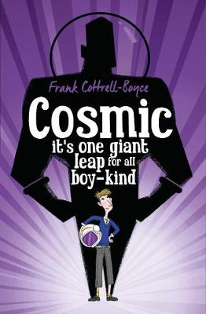

Science

Animals, including humans

Comparing the life cycles of insects, amphibians, birds and mammals.

To describe the changes as humans, develop to old age.

Does the largest animal have the longest gestation period?

Puberty talk with the school nurse.

Working scientifically and types of enquiries.

Using secondary sources of information.

Pattern seeking.

Close observational skills over time.

Art

Painting and mixed media: portraits.

In Art this term the children will develop their skills by using a range of materials and experimenting with different art and crafts. They will focus on drawing, painting and sculpture with a range of materials. They will also learn about an artist using these techniques to create their art.

Computing

In computing the children will develop their understanding of computer systems and how information is transferred between systems and devices. They will explain the input, output, and process aspects of a variety of different real-world systems. They will also take part in a collaborative online project with other class members and develop their skills in working together online.

RE

What does it mean to be a Muslim in Britain today?

What is a special place for Muslims? Why are the 5 pillars of Islam important to Muslims? How does Shahadah affect the life of a Muslim?

Music

This term the children will be working on their Keyboard skills. By the end of the term the children will know the names of the white keys, will learn simple tunes from notation and use the correct technique. They will be able to play a C major scale.

PSHE

This half term we will be looking at the food choices we make and answering the following questions: Are we a healthy bunch? Which is the healthiest menu? What do we need to do to be healthier? Are all images we see in the media true?

We will also be looking at physical contact and answering the question how important is touch?

Geography

In geography this term, the children will be learning about North America. By the end of this unit, they will have knowledge of the key physical and human features of North America and be able to locate and describe Mexico. Pupils will further be able to make geographical comparisons to where they live.

PE

For outdoor PE, the children will be doing outdoor adventure activities. During these lessons the children will work as a part of a team to solve problems, use a map to navigate an area and work on working under time pressures.

In archery, the children will learn the techniques needed to shoot an arrow effectively. They will develop the correct stance, and how to improve their accuracy. They will learn how to set up, and be safe, on a traditional archery range.