**Year 5**

English

This term in Writing, we will be writing a story and a persuasive argument. The story is about a present and is a story with an underlying meaning. The persuasive argument is about living in the rainforest. In reading, we will be continuing to develop comprehension and fluency skills through the reading of our class novel Stormbreaker by Anthony Horrowitz.

Maths

In maths this term we will be learning to multiply and divide using short and long multiplication methods and short division methods. We will also be continuing to learn about fractions, including equivalent fractions, fractions of amounts, adding and subtracting fractions, converting between mixed numbers and improper fractions and multiplying fractions by integers.

This means we need to be very secure in our recall of times tables facts so this needs lots of practice at home.

**Spring 1**

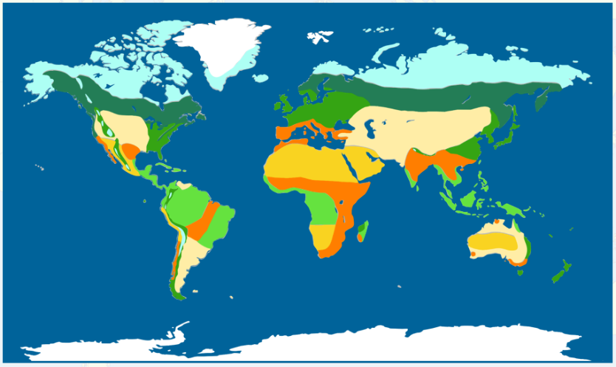

Music

In music, we will be learning all about Samba music, instruments and syncopation. We will learn to follow and blend several rhythms with accuracy on different instruments.

Art

Our unit this half term is entitled I need Space. The children will Use past knowledge and experience to explore a range of drawing processes. They will select and place textures to create a collagraph plate and print.

RE

This term we will answering the big question, ‘If God is everywhere, why go to a place of worship?’ through studying how Christian, Jewish, Hindu and Muslim beliefs shape their different places of worship. We will be looking at different types of places of worship.

PSHE

In PSHE this term, we will be talking about healthy lifestyles. We will be thinking about the three aspects of a healthy lifestyle: physical, emotional and mental health. We will be looking at how we can have a healthy lifestyle and who can help us.

PE

This term the children are working on gymnastics and on being leaders of PE - planning and leading games they have designed themselves with younger children.

Computing

This term the children are working on digital creativity, creating and editing their own videos with a message. They will learn how to take different types of shots and add audio and effects.

Science

This half the term, the children will be continuing with their work on properties and changes of materials. They will be considering making solutions and mixtures and how these can be separated by sieving, use of magnetism, filtering and evaporation. They will be looking at the work of chemists and how materials change when heated, whether changes are reversible or irreversible forming a new material.

Geography

This half term, we will be answering the question, ‘What are Biomes?’ Children will learn about the location of biomes building on their previous work on the Tropics and climate zones. We will focus on the savanna, desert and rainforest biomes with a case study of the Amazon Rainforest and look at how plants, animals and humans inhabit these biomes**.** We will also be thinking about deforestation and desertification.