Year 6
English
In writing, our first unit is based around the story The Firework Maker’s Daughter. We will write our own story extract, using the book as a starting point. We will then complete a writing unit based on our class novel, Goodnight Mister Tom by Michelle Magorian.
Throughout the half term, our reading comprehension lessons will be based around our class novel. Children will locate answers in the text, using inference and deduction as necessary.

Maths
We will start this term by looking at place value up to ten million. We will partition, order and round whole numbers.
After the children are confident with their place value, we will move onto calculations for addition, subtraction, multiplication and division. Children will be asked to apply their calculations while solving a range of single and multistep problems.
We will be encouraging children to practice and consolidate their times tables knowledge and key facts for homework.
Children will continue to take fortnightly arithmetic tests.
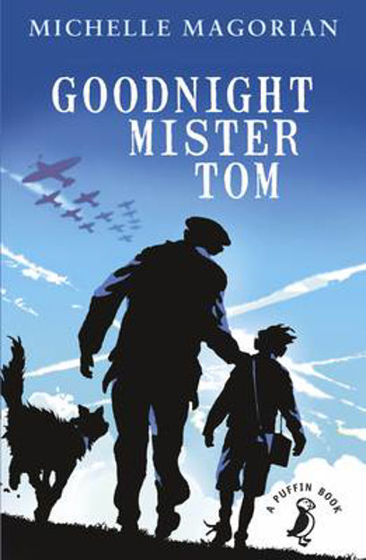
Autumn 1

PE
In PE we will be covering basketball during September, and netball during October. We will practise skills such as passing the ball and working as part of a team. Each lesson will begin with fitness activities to build cross country stamina. In addition there will be time on the outdoor gym and planned activities over lunch.
RE
Our Big Question this half term is, ‘What do religions say to us when life gets hard?’
We will seek to answer this question by learning about Christianity, Islam and Non-religious beliefs and views.

Music
This half term, the children will be exploring dynamics, pitch and texture using Fingal’s Cave by Mendelssohn as a stimulus. They will create a group composition, create a graphic score to record their sounds, and will look at the role of the conductor.
PSHE
In PSHE, we will be thinking about relationships. This will cover a range of topics including relationships with authority, relationships in secondary school and how we can show respect within our relationships.

Art
We are developing photography skills and techniques to design a range of creative photographic outcomes. We will then move on to analysing and evaluating artworks. The children will exploring various artists and research their techniques and artistic intentions. They will be collecting ideas in sketchbooks, planning for a final piece and presenting what they have learnt.
Computing
This half term we will be learning about concept of variables in programming through games in Scratch.
Children will identify where they see variables used in daily life and what a variable is, before creating programs which use variables to create scoring systems.

Geography
This term we will be learning about South America. The children will be identifying the countries that make up South America, along with cites and geographical features. Within the unit, we will be using atlases and understanding more about what it would be like to live in a South American country.
Science

Our first topic this half term is animals, including humans. The children will build on their knowledge from previous years. We will begin with reviewing their understanding of the body and key vocabulary used to identify organs and skeletal structure. Within the Y6 syllabus, we will then take a look at the human circulatory system, and describe the functions of the heart, blood vessels and blood.

By the end of the unit, the children will be able to recognise the impact of diet, exercise, drugs and lifestyle on the way their bodies function. Additionally, they will be able to describe the ways in which nutrients and water are transported within animals, including humans.

Throughout the unit, we will be using scientific skills by planning investigations, recording findings, identifying what makes a fair test and presenting conclusions.

