**Year 6**

English

The first genre we will cover in our English is narrative in the form of a horror. We will be using the Write Stuff approach and continue to sentence stack. Then the children will write their own. We will then be completing writing unit based on our class book Goodnight Mister Tom by Michelle Magorian.

Throughout the half term we will read our class book and will complete comprehension questions relating to the chapters.

Maths

We will start this term by looking at place value up to ten million. We will partition, order and round whole numbers.

After the children are confident with their place value, we will move onto calculations for addition, subtraction, multiplication and division. Children will be asked to apply their calculations while solving a range of single and multistep problems.

We will be encouraging children to practice and consolidate their times tables knowledge and key facts for homework.

Children will continue to take fortnightly arithmetic tests.

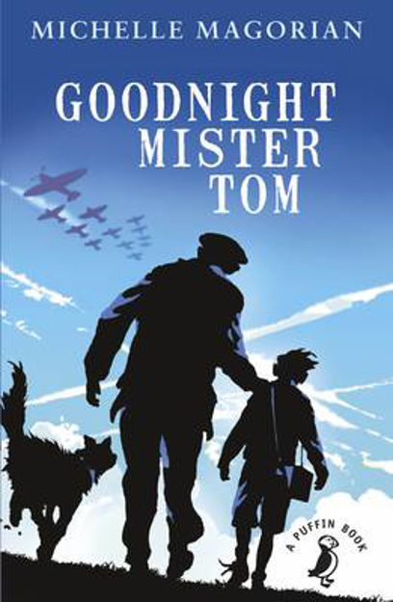**Autumn 1**

Music

This half term, the children will be developing their skills in rhythm and performance. They will learn to play a variety of percussion instruments and develop the skills of African Drumming to create ensemble pieces.

PE

This year the 2 hours allocation for PE will consist of one and a half hours of a lesson, in addition to time on the outdoor gym and planned activities over lunch. The lessons will be split between health related fitness and Dodgeball. These lessons will be taught by either Mr Walker Mrs Halkyard.

RE

Our Big Question this half term is, ‘What do religions say to us when life gets hard?’

We will seek to answer this question by learning about Christianity, Islam and Non-religious beliefs and views.

PSHE

In our PSHE, we will be developing our emotional literacy, through the use of zones of regulation.

Exploring the different zones, what they look like and tools to support us with the different zones. This is a new whole school approach we will be using.

Art

We are developing photography skills and techniques to design a range of creative photographic outcomes. We will then move on to analysing and evaluating artworks. The children will exploring various artists and research their techniques and artistic intentions. They will be collecting ideas in sketchbooks, planning for a final piece and presenting what they have learnt.

Computing

This half term we will be learning about concept of variables in programming through games in Scratch.

Children will identify where they see variables used in daily life and what a variable is, before creating programs which use variables to create scoring systems.

Geography

This term we will be learning about South America. The children will be identifying the countries that make up South America, along with cites and geographical features. Within the unit, we will be using atlases and understanding more about what it would be like to live in a South American country.

Science

Our first topic this half term is animals, including humans. The children will build on their knowledge from previous years. We will begin with reviewing their understanding of the body and key vocabulary used to identify organs and skeletal structure. Within the Y6 syllabus, we will then take a look at the human circulatory system, and describe the functions of the heart, blood vessels and blood.

By the end of the unit, the children will be able to recognise the impact of diet, exercise, drugs and lifestyle on the way their bodies function. Additionally, they will be able to describe the ways in which nutrients and water are transported within animals, including humans.

Throughout the unit, we will be using scientific skills by planning investigations, recording findings, identifying what makes a fair test and presenting conclusions.