**Year 6**

English

The first genre we will cover in our English lessons is persuasive text in the form of a letter. We will be using the Write Stuff approach with increasing independence. Our second writing piece will be a recount. Both writing units will be based on our class book. We will be reading a new class book, A Christmas Carol by Charles Dickens and will complete comprehension questions relating to the chapters.

We will continue to work through the Year 5/6 spellings in class, learning patterns and spelling rules.

Maths

Firstly, we will consolidate the application of the four operations learnt in Autumn 1. We will then spend quite some time on fractions: learning to find equivalents, adding and subtracting, and multiplying and dividing fractions. The children will be taught how to apply these processes to problem solving. We will then move on to converting metric and imperial measures.

We will continue to encourage children to practice and consolidate their tables’ knowledge and arithmetic skills.

**Autumn 2**

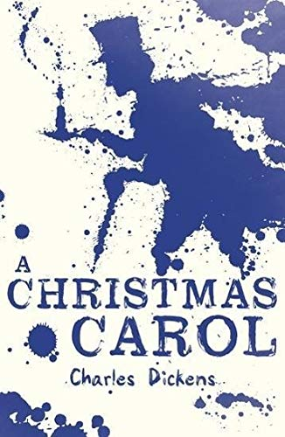

PSHE

In our PSHE, we will be learning the importance of equality, the impact of discrimination on society and how stereotypes are shaped. Furthermore, we will discuss the importance of the family within different cultures and describe the difference between identity, diversity and culture.

Science

Firstly, we will consolidate our understanding on the circulatory system and the impact of lifestyles.

We will then focus on our new topic, Evolution and adaptation. The children will be learning about how all animals and pants vary and how these variations are passed on to their offspring.

 We will be exploring how animals are adapted to their environments and researching the characteristics of animals and plants that live in hot places (deserts) and cold places (the arctic). How do their characteristics help them to survive?

We will then finally move onto looking at the work of Charles Darwin and how his discoveries and the fossil record give us evidence to support theories of evolution. We will also be thinking about the differences between natural selection and artificial selection (breeding).

PE

This half term the children will begin their sessions with dance, using a thematic approach based on the war. The children will also be learning the skills and rules to play hockey. Over the term, they will develop their dribbling, shooting and passing which will then be applied to games.

DT

This half term we will be designing a waistcoat in accordance to a specific design criteria. This will involve: annotating designs, using a template, marking and cutting fabric accurately, and sewing. Throughout this unit children will be evaluating their work continually as it is created.

History

This half term we will be learning about the causes and consequences of WW2. Children will look at what paved the way to the start of WW2 after WWI; which countries were at war and how Britain prepared and reacted to being at war. They will also discover the role of women and evacuees; how propaganda was used, the Battle of Britain as a turning point in WWII and how D-Day led to the Allies eventually defeating Hitler and bringing an end to WW2. This unit will provide opportunities to study a range of primary and secondary sources throughout.

RE

We will be continuing our Big Question this half term, ‘What do religions say to us when life gets hard?’

We will seek to answer this question by learning about Christianity, Islam and Non-religious beliefs and views.

Spanish

This half term we will be learning the nouns for parts of the face and body. We will look at the use of singular and plurals by changing the definite article. We will use songs and yoga to help consolidate our learning.

Music

This half term children will be learning about how music is used for different purposes. Linked to our history topic, the children will be learning about WW2 songs and music, including dance music and they will be trying out some swing dance moves.